**Module 4**

**Terms of Reference for Borehole Drilling Works and Pump Supply and Installation**

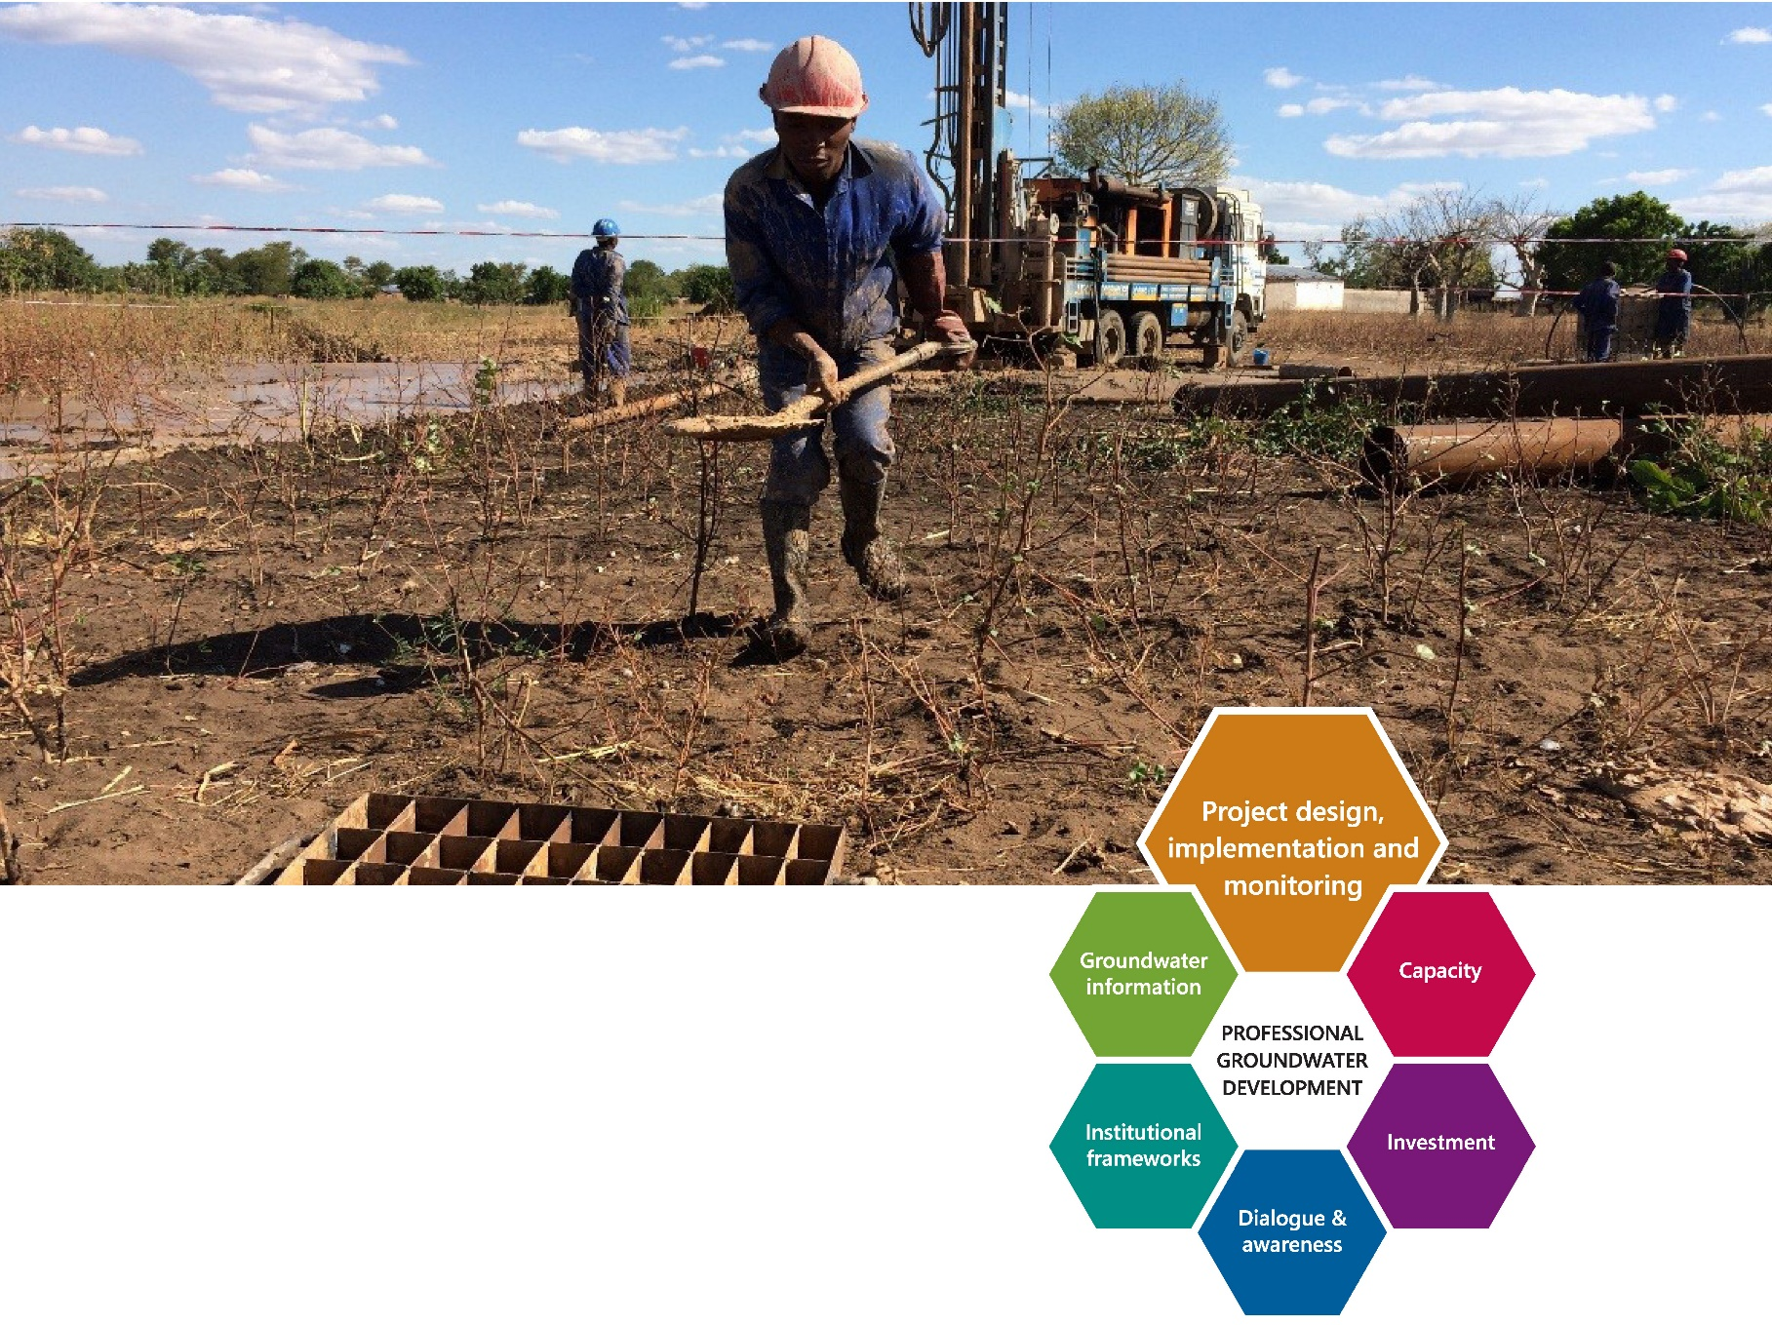



**DISCLAIMER:**

This publication may be reproduced in whole or in part and in any form for educational or non-profit purposes without special permission from the copyright holder provided proper acknowledgement of the source is made. UNICEF and Skat Foundation would appreciate receiving a copy of any publication that uses this publication as a source. No use of this publication may be made for resale or for any other commercial purpose without prior permission in writing from UNICEF. The designation of geographical entities in this report, and the presentation of the material herein, do not imply the expression of any opinion whatsoever on the part of the publisher or the participating organisations concerning the legal status of any country, territory or area, or of its authorities, or concerning the delimitation of its frontiers or boundaries.

**FOR MORE INFORMATION:**

For more information, comments and feedback please contact UNICEF New York headquarters [www.unicef.org](http://www.unicef.org) or Skat Foundation [www.skat.ch](http://www.skat.ch)

**AUTHORS:**

Dotun Adekile & Kerstin Danert, Skat Foundation, St Gallen, Switzerland; Jose Gesti Canuto, UNICEF, New York, USA; Djani Zadi, Peter Harvey, and Anne Cabrera-Clerget, UNICEF, Copenhagen, Denmark

**CONTRIBUTORS:**

Fiorella Polo, WASH Specialist, Water and Sanitation Section, UNICEF New York Headquarters, USA  
Sue Cavill, Consultant

**COVER PHOTO:**

GIFT WANANGWA

**HOW TO CITE:**

UNICEF/Skat Foundation (2018) Module 4 Agreement for Borehole Siting and Drilling Supervision Consultancy In UNICEF/Skat Foundation (2018) Borehole Drilling - Planning, Contracting and Management: A UNICEF Toolkit,Cost Effective Boreholes Partnership of the Rural Water Supply Network (RWSN) by UNICEF and Skat Foundation, Available from [www.unicef.org](http://www.unicef.org) and [www.rural-water-supply.net](http://www.rural-water-supply.net)

DOI: 10.13140/RG.2.2.26315.64801

ISBN: 978-3-908156-62-8



# **Toolkit Orientation Table**

|  |  |
| --- | --- |
|  | **Introduction to the Toolkit** |
|  | * Definition of terms * Background to the Toolkit * Overview of the five modules |
|  |  |
| **Module 1** | **UNICEF Principles for the Planning, Contracting and Management of Borehole Drilling Projects** |
|  | * Clarifies stakeholder responsibilities * Presents eight principles for the professionalization of borehole drilling * Defines minimum standards and recommends procedures * Explains different levels of drilling supervision |
|  |  |
| **Module 2** | **Procurement Considerations for Borehole Drilling Works** |
|  | * Defines procurement process and responsibilities * Provides guidance for risk management * Compares two solicitation methods: ITB and RFPS * Highlights key considerations during the pre-contractual, contracting and contract administration phases including the evaluation of technical and financial proposals and the payment schedule |
|  |  |
| **Module 3** | **Borehole Siting and Drilling Supervision Consultancy** |
|  | * Provides template of Terms of Reference which includes: * Description of the assignment * Supervisor’s checklist * Deliverables and reporting requirements * Suggested Bill of Quantities for the consultancy services * Completion certificate templates * Includes template for UNICEF Agreement for Borehole Siting and Drilling Supervision Consultancy Services |
|  |  |
| **Module 4** | **Terms of Reference for Borehole Drilling Works and Pump Supply and Installation** |
|  | * Includes overview of how to select and specify handpumps and assure their quality * Provides templates for: * Terms of Reference for Borehole Drilling Construction and Development of the Borehole * Terms of Reference for the Supply and Installation of Pumps * Provides Technical Specifications for the borehole and a suggested format for the borehole completion record |
|  |  |
| **Module 5** | **UNICEF Request for Proposal for Services for Borehole Drilling Works** |
|  | * Follows the UNICEF frame of Request for Proposal for Services in VISION and advises on options and elements * Includes template Bill of Quantities for borehole drilling works |

## Module 4 - Contents

[Abbreviations 5](#_Toc530994406)

[Introduction 6](#_Toc530994407)

[Module Formatting 6](#_Toc530994408)

[**Borehole Numbers** 6](#_Toc530994409)

[**Contract Options** 7](#_Toc530994410)

[**Handpump Guidance** 9](#_Toc530994411)

[**Selecting and Specifying Handpumps 9**](#_Toc530994412)

[**Quality Assurance of Handpumps and Spare Parts 12**](#_Toc530994413)

[**Ordering Handpumps 12**](#_Toc530994414)

[**Terms of Reference for the Drilling Construction and Development of the Borehole – Template 14**](#_Toc530994415)

[Abbreviations 14](#_Toc530994416)

[1. Project 15](#_Toc530994417)

[2. Description of the Assignment 15](#_Toc530994418)

[3. Deliverables 29](#_Toc530994419)

[4. Reporting Requirements 29](#_Toc530994420)

[5. Location and Duration 31](#_Toc530994421)

[6. Evaluation Process and Methods 31](#_Toc530994422)

[7. Project Management 32](#_Toc530994423)

[8. Payment 32](#_Toc530994424)

[**Terms of Reference for the Supply and Installation of Pumps - Template 33**](#_Toc530994425)

[Abbreviations 33](#_Toc530994426)

[1. Project Background 33](#_Toc530994427)

[2. Description of the Assignment 33](#_Toc530994428)

[3. Deliverables 35](#_Toc530994429)

[4. Reporting Requirements 36](#_Toc530994430)

[5. Location and Duration 36](#_Toc530994431)

[6. Evaluation Process and Methods 36](#_Toc530994432)

[7. Project Management 36](#_Toc530994433)

[8. Payment 37](#_Toc530994434)

[**Annexes – Toolkit Module 4** 38](#_Toc530994435)

[**Annex 4.1 Borehole drilling – different contract modalities explained 38**](#_Toc530994436)

[**Annex 4.2 Technical Specifications for the Borehole 41**](#_Toc530994437)

[**Annex 4.3 Suggested Format for Borehole Completion Record 45**](#_Toc530994438)

[**Annex 4.4 Pumping Methods - Handpumps 59**](#_Toc530994439)

[**Annex 4.5 Guideline for Quality Assurance of Handpumps and Spare Parts 64**](#_Toc530994440)

## List of Tables

Table 4.1 Allocation of Boreholes 29

Table 4.2 Recording and Reporting for Borehole Construction 30

Table 4.3 Example of Milestones for Borehole Drilling Contract 32

Table 4.4 Allocation of Pump Installation sites 35

Table 4.5 Example of Milestones for Pump Supply and Installation Contract 37

## List of Boxes

Box 4.1 Handpump Standardisation in sub-Saharan Africa in 2015 10

Box 4.2 Matrix overview of commonly used pumps for community water supplies 11

Box 4.3 Example of specification for a complete Standard Deepwell Pump 12

Box 4.4 Example PVC casing and screen dimensions 21

## Abbreviations

ITB Invitation to Bid

NGO Non-Governmental Organisation

QA Quality Assurance

RFP Request for Proposal

RFQ Request for Quotation

TIP Technology Information Packages

ToR Terms of Reference

uPVC unplasticised polyvinyl chloride

VLOM Village Level Operation and Maintenance

WASH Water, Sanitation and Hygiene

See **Toolkit Introduction** for definition of terms.

## Introduction

The UNICEF Toolkit for Planning, Contracting and Management Borehole Drilling (referred to as the **Toolkit**) has been developed to guide UNICEF staff involved in the procurement of borehole construction and the supply of equipment, as well as contracting consultancy services for siting and supervision to bring uniformity to practices.

**Module 4** provides an overview of contract options as well as guidance and advice for the preparation of Terms of Reference (ToR) for (i) borehole drilling works and (ii) Pump Supply and Installation. These two ToRs define the scope of work and set out the responsibilities of the Drilling Contractor, Pump Supplier and other stakeholders. Each ToR forms the basis for the preparation of the technical and financial proposals by the bidders, and subsequently becomes an integral part of the contract. The module is structured according to the UNICEF standard structure of ToR, in the form of templates that can be modified to suit local requirements.

In order to avoid any ambiguities from the pre-contractual phase to the execution of services, it is extremely important to have clear ToR. These will guide the supplier(s) in the proposal preparation, provide the basis for a smooth implementation of the project and limit the risks of misunderstanding and, consequently, of disputes and claims. When developing ToR it is advisable to consult widely to make sure that they are accurate, realistic and include realistic targets.

As noted in the **Toolkit – Introduction** and **Toolkit – Module** 1, there are two options for the client (i.e. the organization or agency that is contracting out the borehole construction):

UNICEF as Client – in the case of boreholes that are directly contracted by UNICEF, the Client is the UNICEF Country Office

Government or NGO as Client – in the case where UNICEF supports National Government or an NGO to contract boreholes the client is the respective National Government or NGO.

Module 4 of the **Toolkit** is intended for the option of UNICEF as client, although it can also be used as a guide for other organizations. The term client, rather than UNICEF, is used throughout the template ToR. The term Designated Representative is used to refer to the officer that is designated to represent the client in the contract.

## Module Formatting

The **Toolkit** provides flexibility so that it can fit the circumstances of a particular project. It should be noted that national laws, standards and codes are to be adhered to, unless otherwise specified. Options for modification to some clauses to suit particular situations are shown with notes in ***[bold italics highlighted in grey]***. Advice and key elements (such as relevant principles) to take into consideration are highlighted in blue text boxes throughout the document (e.g. Box X).

Box X Sample box containing advice and key elements that should be taken into consideration

|  |
| --- |
| When commencing with an Invitation to Bid, UNICEF procurement …... |

## Borehole Numbers

The ToR Template (section 2.9.4, 2.11.4, 2.14.2 and Table 4.1) refers to borehole numbers. Where there is no national borehole numbering system, UNICEF should initiate a system of numbering based on the 1:100,000 topographic map sheets. Each number will consist of the appropriate sheet number followed by the quadrant (NW, NE, SW, or SE), which is followed by a serial number, e.g. 101 SE 1 stands for borehole no. 1 on topographic map sheet no. 101 SE. It can subsequently be mapped on the topographic sheet by its GPS coordinates.

## Contract Options

Boreholes need to be properly sited by experienced and qualified personnel using scientific methods and established good practices. As stated in the **Toolkit** – Module 1, Principle 3 (Borehole siting practice), for projects where more than five boreholes are drilled or that take place in difficult groundwater terrains, UNICEF should separately contract a hydrogeologist/groundwater to carry out borehole siting. Siting is further detailed in Module 3 of the **Toolkit** (including a template Terms of Reference). On small projects (i.e. where up to five boreholes are drilled), located in areas where the groundwater is easily accessible, the responsibility for siting may be given to the Drilling Contractor. In such cases, the Terms of Reference for drilling works set out in Module 4 need to be adjusted accordingly.

In order to ensure that boreholes are drilled according to the technical specification, borehole drilling should be supervised by competent persons or firms. Experienced hydrogeologists/groundwater specialists shall be engaged to carry out the supervision of borehole drilling. Supervision is further detailed in Module 3 of the **Toolkit (**including template Terms of Reference for Supervision). The siting and supervision of a particular borehole should be carried out by the same person or firm.

The supply and installation of the pump can be undertaken by the Drilling Contractor/partner NGO, or Pump Supplier. Requirements for the supply and installation of the pump and training are set out in the **Toolkit**, Module 4 – Terms of Reference for Pump Supply and Installation. If these activities are to be taken by the Drilling Contractor, Terms of Reference and Bill of Quantities need to be adjusted accordingly.

If boreholes specifications are not followed or borehole designs do not take the prevailing geological and groundwater conditions into account, the borehole may work for the first few weeks, or even up to the end of the defects liability period, but can silt up slowly, and prematurely fail, be prone to contamination, or pump components can corrode. In order to provide the foundation for sustainability of the supply, UNICEF needs to select the appropriate contract option and properly manage it as outlined in the **Toolkit** Module 2, ensuring that adequate resources for a high quality borehole to be constructed are provided.

In the past, UNICEF country offices have tended to use turnkey contracts in which the siting, drilling and pump installation is combined into one contract. Since the Drilling Contractor is responsible for the siting, he/she is usually only paid for productive, or so-called “wet” boreholes. While this means that UNICEF can claim to only be paying for successful boreholes, the reality is that:

1. estimating drilling costs that account for the risk of a dry borehole is extremely challenging for UNICEF (and can lead to unrealistic engineers’ estimates/confidential Bills of Quantities);
2. estimating the costs and preparing quotes is extremely challenging for the Drilling Contractor (which can lead to unrealistic quotations in the bid); and
3. the Drilling Contractor has to recover the costs of non-productive boreholes somehow.

The Drilling Contractor can address point (iii) by:

1. charging the client more for successful boreholes;
2. underpaying (and thus demoralising) staff;
3. cutting corners with respect to materials used or development (and undermining quality and longevity of the borehole);
4. siting boreholes in areas that are more likely to be successful but are further from the community, such as near swamps, wetland or river banks, and are in danger of contamination in floods.

None of the above are desirable.

While turnkey contracts, if used at all, *should* pay the contractor a fixed sum for the work done as per his/her quotation in the tender, there are cases of clients not paying for non-successful boreholes *and* only paying for the actual work done on successful boreholes. For example, if a borehole is drilled shallower than in the Drilling Contractor’s quote, only the depth drilled is paid. This is a double-blow to the contractor, as it becomes practically impossible to recover the costs of any dry boreholes, and so savings *must* be made elsewhere, as noted in a), b) and c) above.

Turnkey contracts tend to be combined with some monitoring of progress and a final inspection. But there is no professional full-time or part-time/milestone supervision. While this may appear to reduce the cost of the borehole, the reality is that there is no control over the materials used (e.g. casing and screen, gravel pack), and no checks are made to ensure that all steps are properly followed during the construction process (e.g. length and positioning of screen, borehole development, pumping test, sanitary seal). The final inspection becomes extremely critical, and needs to follow rigorous criteria or a checklist as well as the deployment of a borehole camera to verify the borehole design and depth. The pumping test will most likely also have to be repeated.

So while turnkey contracts seem advantageous to the client as they are simpler to administer, they are risky, and depend entirely on the capability and integrity of the Drilling Contractor (even if he/she will make a loss as a result), as well as the willingness of the contractor to take a gamble on the risk of drilling a dry borehole.

The alternative to the aforementioned turnkey contracts is to issue separate contracts for (i) siting/supervision, (ii) drilling (which may or may not include pump supply and installation). Ideally, the siting is completed first, with the borehole designs availed in full in the procurement of the Drilling Contractor. While this makes it much easier for the Drilling Contractor to prepare estimate the costs and logistical implications when preparing the tender, it means that two rounds of tendering are required. If tendering only takes place once a year, it may be advantageous to site in one year, and tender the drilling in the following year. Likewise, if the siting is tendered at the same time as the drilling, the Drilling Contractors do not have the full details they require, and have to make considerable guesses when preparing their bids.

With separate contracts, Drilling Contractors should be paid for the work done according to a bill of quantities. The disadvantage of this method is that UNICEF has to openly acknowledge that there is need to pay for boreholes that, despite being sited professionally, do not yield sufficient water. This needs to be communicated to the donors, who have to understand that there are risks associated with borehole drilling, and that, rather than hiding them by passing them to the Drilling Contractor, with this method, they are being set out in the open.

The advantage of separate contracts for siting/supervision and drilling is that:

1. borehole designs are more realistic and
2. supervision enables UNICEF to pay only for the work done, which is fairer to the Drilling Contractor and to UNICEF.

As the Drilling Contractor is paid for the work done, there is no need for him/her to cut corners to recover losses associated with dry boreholes. However, skilled Supervisors are required, which may call for additional efforts to raise in-country capacity. Also, Supervisors need to be properly remunerated and available on-site.

Having separate contracts for siting/supervision and drilling but not supervising properly is no better than using a turnkey contract.

In order to prevent the method of separate contracts and payment according to bills of quantities from being abused, (e.g. through collusion between the Drilling Contractor and the Supervisor) it is important that there is quality control of the siting process and the drilling supervision. National regulation of the groundwater consultants can help. And thorough inspection of the completed borehole by third party monitors who have been trained and use a checklist is advisable.

Last but not least, the pump supply and installation can either be included in the drilling contract or be a separate contract. Administratively, it seems easier to put the drilling contract and pump supply/installation together. However, given the challenges of assuring the quality of pump components being imported into many countries, there is needed to certify Pump Suppliers. If there are numerous Drilling Contractors, it becomes difficult to ensure that every contractor is installing pumps from the certified Suppliers.

A separate contract for the supply and installation of pumps should make it easier for the client to control the quality of the pumps. However, it is important that the project is managed well to ensure that there are not substantial delays between the borehole completion and the pump installation (which can lead to vandalism and loss of the hole). In addition, the construction of the platform (by the Drilling Contractor) needs to be coordinated with the installation of the handpump stand (by the Pump Supplier). An alternative approach is to contract the construction of the concrete platform, drainage channel and soak-pit to the Supplier.

The advantages and disadvantages of different contract mechanisms, including siting, supervision pump supply and installation activities, are further detailed in Annex 4.1.

## Handpump Guidance

### Selecting and Specifying Handpumps

This **Toolkit** focuses on handpumps with standard RWSN and/or India Bureau of Standards specifications0F[[1]](#footnote-1) plus two commonly used private domain pumps (Volanta and Vergnet Hydropump 60). It is intended to enable users to specify the exact pump they have chosen, with all available options, to prepare the corresponding Bill of Quantities and define procedure to assure handpump quality.

While worldwide, hundreds of different handpump types are used, most governments and UNICEF adhere to handpump standardization policies (defined above) and thus install a relatively small set of public and private domain handpumps within their programmes.

The benefits of handpump standardization include familiarity, availability of spare parts and, backup through trained mechanics tend to outweigh any negative aspects. A familiar, established technology supported by efficient after-sales and repair services is often a better choice than the least expensive option in terms of cost of the hardware alone. Governments, project planners and decision-makers should be aware that their selection of technology has to fit within the prevailing handpump standardisation mechanisms of the respective country. Any deviation from standardisation policies/guidelines should have clear justification and should occur only with the written agreement of the national government.

Box 4.1 Handpump Standardisation in sub-Saharan Africa in 2015

*“In a handful of countries, handpump standardisation includes standard handpump designs. With over a million handpumps in sub-Saharan Africa and new installations every day, handpump standardisation is still vital for the policy and practices of governments and implementing organisations. While rural water practitioners are polarised about the future of formal standardisation, the extent of informal standardisation is of significant importance to the sustainability of handpumps across the continent. Of the countries in sub-Saharan Africa using handpumps, formal standardisation has emerged in fifteen through regulations (nine countries), and endorsements (six countries). However in the remaining countries, informal standardisation determines what handpumps are installed where, either through recommendations (fourteen countries), or de facto standardisation (six countries).”* (McArthur, 20151F[[2]](#footnote-2))

A great variety of handpumps for water lifting are available, but in reality the feasible technology options are usually limited. Hydrogeological conditions, strategic decisions at national level, project execution policies and government decisions to standardize may restrict the choice. The final choice of technology should rest with communities themselves, since they are normally responsible for the management of their water supply system.

In areas with aggressive/acidic groundwater (i.e. with a pH value < 6.5), it is essential to ensure that pumps are corrosion-resistant. Pumps that corrode are generally not accepted, because they produce iron-tainted water that tastes bad and stains food and clothing.

Some pumps were designed as a family pump to serve small user groups. These pumps are generally simple and cheap. However, they are not robust enough to serve large user groups. For groups of more than 100 users, it is essential to use community pumps designed for large groups of people.

Shallow well applications allow simple suction pumps, which can only be used to a pumping lift of a maximum of 7 metres or direct action pumps, which can be used to a pumping lift of a maximum of 15 metres (that is, the depth of the wells must be less than 7 m and 15 m respectively). Deep well pumps can cover the complete range of installations, but they are an unnecessary and very expensive option for shallow sources. For more details on pumping methods, see Annex 4.4.

The simplicity of making the most common repairs, (replacing seals, replacing fulcrum and handle bearings, removing of piston and foot valve) affects the ease of repair. Village-level operation and maintenance (VLOM) is possible in cases where handpumps require only a few low-cost tools, and that maintenance and repair can be carried out by village mechanics or communities themselves. Heavy and complex tooling makes motorized central maintenance teams necessary. This affects the cost of repairs and the time that the pump is out of service.

An open-top cylinder design allows the retrieval of piston and foot valve without the need for lifting the rising mains. This makes this type of pump more suitable for repairs by the community. Users prefer pumps that have a high yield. In addition, the look and feel of a pump can affect its acceptability. In some cases, cultural aspects like pumping position are important factors in users' preference.

Box 4.2 Matrix overview of commonly used pumps for community water supplies

****

UNICEF Supply Division has two sources of information dedicated to the selection and specification of handpumps as follows:

1. [UNICEF WASH Technology Information Packages (TIPs)](https://www.unicef.org/supply/index_54301.html)2F[[3]](#footnote-3) – available on the Internet
2. [The Supply Catalogue](https://supply.unicef.org/unicef_b2c/app/displayApp/(cpgsize=0&layout=7.0-12_1_66_68_115_2&uiarea=2&carea=536941D1FDDF0B6FE10000009E710FC1&cpgnum=1&citem=536941D1FDDF0B6FE10000009E710FC14EBAFE42BBC20F68E10000009E71143E)/.do?rf=y)3F[[4]](#footnote-4) – available on the UNICEF Intranet

The UNICEF WASH TIP 1 (out of 5) is dedicated to handpumps and offers useful information on selection criteria for handpumps, pumping methods, and proposes a handpump selection tool to help decision-making regarding appropriate technology choice. [The Supply Catalogue](https://supply.unicef.org/unicef_b2c/app/displayApp/(cpgsize=0&layout=7.0-12_1_66_68_115_2&uiarea=2&carea=536941D1FDDF0B6FE10000009E710FC1&cpgnum=1&citem=536941D1FDDF0B6FE10000009E710FC14EBAFE42BBC20F68E10000009E71143E)/.do?rf=y) references commonly procured handpumps, and for each reference, it has instructions for use and recommendations.

UNICEF’s approach provides flexibility to select pumps with quantity and type of connecting rods/riser pipes suitable to a particular water condition and the well depth. It is essential that the client has a good technical understanding of the handpump technology, to thus avoid selecting the wrong combination of components to make one complete handpump, or components that are not in line with the requirements (such as non-corrosive materials).

### Quality Assurance of Handpumps and Spare Parts

The aim of Quality Assurance is to ensure that handpumps supplied are of acceptable quality as defined in the handpump specifications. In order to assure quality, there is need for country offices to optimize the process of handpump inspections and testing. This process evaluates the quality of the product, the quality assurance procedure employed by the Supplier and the performance history of the company or product.

Annex 4.5 provides criteria to categorize hand pumps into High Risk or Low Risk and evaluate the technical performance of handpumps and spare parts. Criteria for inspection, product and supplier are defined, and specific information about applicability of the criteria is provided. Annex 4.5 also provides information related to handpumps, to assess current in-country quality assurance mechanisms to contribute to adequate Quality Assurance systems and support governments and other development partners to ensure good-quality hand pumps. The guidance aims to assist country offices in the preparation, choosing and managing of quality inspections and testing. A description of country office responsibilities and elements that should be reviewed in the evaluation and approval process for quality assurance inspection and/or testing agencies is presented.

### Ordering Handpumps

To assist in the selection of the pump and for easy specification and procurement, an approach using a full package of a handpump for a particular well depth is recommended. A specification for handpumps should always be broken into a set of components, as shown in the example below for a Standard Deepwell Pump or India Mark II handpump.

It is recommended that adequate sets of Standard Tools and Special Tools for Installation and Maintenance be ordered for installation and maintenance of the handpumps4F[[5]](#footnote-5). The actual numbers being ordered will depend on the density of handpumps in a given area, the installation and maintenance infrastructure and other local conditions. The number of the tool sets being ordered could vary between one set of each type of tools for every 50 pumps to 250 pumps. Similarly, sets of fishing tools for retrieving dropped below-ground components and platform shuttering set and masonry tool set could be ordered at the rate of one each of these items per 250 to 500 handpumps, depending on local conditions.

Box 4.3 Example of specification for a complete Standard Deepwell Pump to be installed to a maximum depth of 30m in water with pH > 6.5

|  |
| --- |
| **General Description:**  Standard Deepwell Pump complete (as per IS 15500:2004 of the Bureau of Indian Standards)  or India Mark II (as per RWSN/SKAT specifications Rev. 2, 2007 ) with 30 metres of galvanised iron riser pipe and connecting rods  **Supplied with:**  1 No. Head assembly (with Handle assembly). 1 No. Water Tank – Standard  1 No. Third Plate  1 No. Telescopic Stand5F[[6]](#footnote-6) – Standard  1 No. Cylinder assembly – Standard  10 Nos. Connecting rods (mild steel, electro-galvanised, 12 mm diameter, 3 m long, with M12 threaded ends and couplers).  10 Nos. Riser pipes (MS, hot dipped galvanised, 32 mm ND, 3 m long).  1 set Spare part kit sufficient for 2 years of operation (optional –Depending on the approach to supply chains for spare parts the spares may be supplied through other channels |

The UNIEF WASH TIP provides information sheets for developing technical specifications and bills of quantities for the following pumps:

No.6 Handpump

Rope Pump, Nicaragua and Madagascar

Malda Pump

Nira AF85 Pump

Tara Pump

Jibon Pump

Walimi Pump

India Mark II

India Mark III

U3M Pump

Afridev

Indus, Kabul, Pamir

Bush Pump

Volanta Pump

Vergnet Hydropump HPV 60 / HPV 100

## Terms of Reference for the Drilling Construction and Development of the Borehole – Template

### Abbreviations

“ inches

cm centimetre

DTH down-the-hole

GPS Global Positioning System

LTA Long Term Agreement

m3 cubic metre

m metre

mm millimetre

no. Number

NTU Nephelometric Turbidity Unity

PPM parts per million

RFP Request for Proposal

RFPS Request for Proposal for Services

ToR Terms of Reference

uPVC unplasticized polyvinyl chloride

### Project

#### **Background**

*The general information must describe the background of the requested services, in particular:*

*Rationale and key aspects of the overall context of the assignment*

*History of activities to date*

*Project/assignment related data, e.g. relevant studies, geographical data target groups, category of services to be rendered and basic documents.*

### 2. Description of the Assignment

#### 2.1 Scope of Work

The Contract to be established is for the drilling, construction and development of ***[Insert number of boreholes]*** boreholes in ***[Insert the Districts]***. ***[Insert the number of boreholes that will be on each of the different geological terrains envisaged, e.g. number in the crystalline basement complex terrain; number on compacted sediments; the number on unconsolidated sedimentary terrain; number that shall be in alluvial deposits]***. The boreholes are to be completed with nominal ***[insert diameter]*** uPVC casing and screens.The Drilling Contractor shall be responsible for drilling, installation of casings and screens, gravel pack, sanitary seal borehole development, pumping test, water quality testing, and construction of aprons, drainage and soakaways. Where access conditions are difficult, it is expected that the Drilling Contractor shall make allowances for this as part of the drilling cost.

***[Insert duration and expected started time of the project]***

The project shall be under the control of the Designated Representative appointed by the client. The Designated Representative shall appoint one or more Supervisors who shall be responsible for the management and direction of the project on site and shall approve all materials supplied, works, and measurements carried out by the Drilling Contractor and his team of workers on the project.

#### 2.2 Work Schedule

The bidder shall submit a comprehensive work schedule within his proposal which should fall within the period specified in the Terms of Reference. The work schedule shall include setting up the base camp, moving the drilling units and support equipment from one drill site to the next within the area of the project. It shall also include the pre-mobilisation meeting.

Once the contract is awarded, and prior to mobilisation to the base camp, or first drilling site the Drilling Contractor shall be required to submit the schedule for the completion of the works in a Gantt chart of weekly activities as specified in in the Terms of Reference. This schedule shall be checked and approved by Consultant. The schedule is to be updated at least monthly.

#### 2.3 Mobilization

Prior to mobilization to the site, the representatives of the Drilling Contractor shall, in the company of the Supervisor or Designated Representative ***[Delete as applicable]***, visit the beneficiary communities to plan take-over of the sites and to agree the start-up date of the project.

Mobilization shall start with the Drilling Contractor establishing a base camp for housing the Drilling Contractor’s staff, storage and maintenance of plant and machinery, supplies and all other equipment required to launch and execute the project. The Drilling Contractor shall make his own arrangement to acquire or lease the land necessary for the establishment of the base camp and safety for all the staff and the community. However, the location of the base camp shall require approval of the Supervisor.

***[Delete the following paragraph if not applicable, such as on small projects where no base camp is required]***.The Drilling Contractor shall submit a plan and layout of the proposed base camp for the approval of the Supervisor with provisions for the following:

Office and residential accommodation and catering facilities for the contractor’s staff

Sufficient storage for the Drilling Contractor’s equipment and supplies including

* fuel storage tanks
* equipment repairs facilities
* covered storage for uPVC casings and screens

The contractor shall, with due care and diligence, execute and maintain the works and provide all labour, materials, equipment, transportation and other facilities necessary to substantially complete the works by the planned completion date, and in accordance with the requirements, documents and the standards defined by it.

The contractor shall take full responsibility for the adequacy, stability and safety of all site operations and methods of drilling, construction and development of boreholes and pump installation and for the security of the site itself, including the security of all materials stored or used on the site.

#### 2.4 Inspection of Materials and Equipment

The Drilling Contractor shall present to the Supervisor the list of equipment and samples of materials to be used on the project as well as relevant information, in sufficient time for the client to complete review of samples. Each item shall be labelled as to origin and intended use in the works.

All materials used in the course of these works shall be new and proper for their use. No reusable materials coming from the site shall be used unless permitted by the client. Other materials shall be stored on site until the end of the works.

All materials, equipment and products shall be installed in accordance with the written recommendations of the manufacturer/supplier. The Drilling Contractor is not allowed to start work until the Supervisor has checked and approved the equipment and materials.

#### 2.5 Traffic & Protection of Roads, Properties & Services

The Drilling Contractor shall carry out all work in connection with the contract so as not to interfere unnecessarily or improperly with the convenience of the public and with access to, use and occupation of roads, footpaths, public services or property not in the contractor's possession.

The Drilling Contractor shall use every reasonable means to prevent damage to roads, bridges and services, and shall select routes and limit extraordinary traffic to avoid unnecessary damage or injury.

Where necessary to divert or control traffic, the contractor shall, in cooperation with traffic control authorities if required, provide all necessary facilities and resources at his own cost.

The contractor shall be responsible for and shall pay the cost of any strengthening or improvement of routes to the site, in order to facilitate movement to site of equipment, temporary works, materials and personnel. This shall apply to all necessary relocation of services.

The above shall also apply to any waterborne traffic required for the works, in so far as it may affect, for example, docks, jetties or sea walls.

The contractor shall bear all costs and charges for special or temporary permits required in connection with access to site.

#### 2.6 Drilling Contractor’s Personnel, Drilling Equipment and Safety Equipment

##### 2.6.1 Personnel

The Drilling Contractor shall provide capable and experienced personnel to perform the work. The Drilling Contractor’s project manager shall be a hydrogeologist or drilling engineer with at least 10 years of drilling experience who shall be responsible for site operations. At each drill site, the Drilling Contractor shall also provide a hydrogeologist ***[Specify degree, diploma or certificate]*** or drilling engineer with at least 5 years’ experience and other suitable staff ***[to be more specific in this section]*** to perform the work. Changes in personnel during the execution of the contract shall be done subject to the approval of the Supervisor or Designated Representative ***[Delete as applicable].*** The Drilling Contractor shall be fully operational, with the drilling unit and installation crew working within two weeks of commencing borehole construction.

***[The years of experience and qualification of the Drilling Contractor’s staff may be modified because in some countries, such personnel may not be available]***

##### 2.6.2 Safety measures and equipment

The Drilling Contractor shall take all reasonable precautions to prevent any injury to persons or death. These precautions shall include, but not be limited to, providing his employees with safety helmets, hard-toed boots and gloves, protection glasses during welding and ensuring that all tools and equipment are in a safe condition and that his employees adopt safe working methods. The Drilling Contractor shall further ensure that his workers have access to an adequate first aid kit.

The Drilling Contractor shall ensure that the site is not accessed by any unauthorized persons. A perimeter barrier must be set up around the drill site to prevent unauthorized access to the drilling site. The Drilling Contractor shall also ensure that children and other onlookers are not allowed to watch any welding, in order to prevent eye damage.

The client shall not be liable for any damages or compensation as a result of accident or injury to any workers employed by the Drilling Contractor, any sub-contractor or any unauthorized persons unless such accidents or injury are caused by an act or default of the client or of nominated representatives of the client.

##### 2.6.3 Fuel and lubricants

The Drilling Contractor shall comply with authorized regulations applicable to the use and storage of diesel, petrol and lubricating oil used at the work site or stored at the base camp, and shall ensure that adequate precautions are taken against fire and environmental contamination. No fuel or lubricant must be transported with any item to be installed in the borehole, in particular the gravel pack, the casings and screens. No leakage of fuel or lubricants that can contaminate surface or groundwater shall be permitted.

##### 2.6.4 Fire prevention

The contractor shall be responsible for fire prevention on the site where the works are being performed. Fire fighting equipment shall be kept on site and under the control of the contractor at all times during the period when works are taking place on the site and during rest breaks. The contractor shall ensure that his employees and sub-contractors can operate the fire fighting equipment. All fire fighting equipment must be in good working condition. The contractor's employees and sub-contractors shall carry out any operations requiring exposed flame or welding in a careful and safe manner.

#### 2.7 Borehole Drilling

The following section assumes rotary and/or down-the-hole (DTH) drilling. ***[Where cable percussion or manual drilling is proposed, the document should be amended accordingly]***

##### 2.7.1 Drilling Methods

The Drilling Contractor shall ensure that the rig is set up at the exact point indicated by the Supervisor. The Drilling Contractor shall be responsible for selecting the appropriate drilling procedure for the geology of each of the project locations. The diameter of the drill hole must be adequate to accommodate the final borehole casing diameter as instructed by the Supervisor plus a minimum annular space of 50 mm. The Drilling Contractor may choose to either drill a hole of adequate diameter on the first pass or to drill a small diameter test hole, then ream to the desired size. Regardless of the procedure adopted by the Drilling Contractor, payment shall only be for the drilled hole at the appropriate size, i.e. additional payment for reaming shall not be made.

The drilling method, drilling rig, drilling fluids and fluid additives are subject to approval of the Supervisor or as stated in the tender documents or national standards. The Drilling Contractor may use any drilling technique he considers suitable to achieve the depth and diameter required, provided that the techniques used are those specified in his tender or are approved by the Supervisor.

The drilling fluids and additives shall consist of water, bio-degradable drilling mud, weight materials (barite or equivalent), fluid loss control materials and foam. The selection, supply and use of drilling additives shall be the responsibility of the Drilling Contractor. Where there are national standards guiding the use of drilling materials, this should be followed. Toxic or unsuitable substances that may adversely affect the quality of the water shall not be added to the drilling fluid. The use of cow dung or bentonite shall be avoided, except where otherwise approved by the Supervisor.

The Drilling Contractor shall be responsible for maintaining the quality of the drilling fluid to assure the protection of the aquifer and other potential water-bearing formations and ensure that good representative samples of the formation material are obtained.

The Drilling Contractor must have the necessary accessories, including sufficient working casings and drill bits to drill through the various formations. In areas of alluvial deposits, drilling through the unstable upper section must be of sufficient diameter to allow the installation of temporary casing which will allow the borehole to be completed at the specified diameter.

##### 2.7.2 Verticality and alignment

The Drilling Contractor shall continuously monitor the weight on the drilling bit to ensure that the boreholes are drilled and cased straight and vertical. The Drilling Contractor shall furnish all labour, tools and equipment to carry out a test for verticality as may be instructed by the Supervisor. Payment shall be on the unit rate as in the bill of quantities.

If so required by the Supervisor, the Drilling Contractor shall demonstrate the verticality and alignment of any borehole by lowering a cylindrical dummy 3 m in length with two metal disks with a diameter of 75 mm at each end, throughout the whole length of the section being tested. Should the dummy fail to move freely throughout this section, or should the deviation from the vertical exceed two thirds of the minimum diameter of the section, the Drilling Contractor shall be obliged to correct the verticality and straightness of the borehole or drill a replacement borehole at his/her own expense.

##### 2.7.3 Protection casings

It is the responsibility of the Drilling Contractor to start drilling at a diameter which will allow the hole to be completed at the specified diameter. Extra casing of a larger diameter to achieve the depth is considered to be part of the contractor's unit rate for drilling.

Temporary protection steel casing shall be installed in every borehole where needed to protect the walls from caving, either suspended by a ground-bearing bracket or correctly anchored in the underlying rock.

Protection steel casing shall have screwed flush joints. The Drilling Contractor shall ensure that it is of sufficient diameter to enable drilling of the complete borehole at the required diameter, together with installation of the permanent borehole casing and screen, and for placing the gravel pack.

For successful boreholes, the protection casings in the soft formations shall be removed from the hole as soon as the borehole has been completed, unless, based on the nature of the geological formation, the Supervisor instructs the Drilling Contractor to do otherwise.

Temporary protection casing must be priced into the drilling cost. It shall not be a separate item on the bill of quantities**.**

##### 2.7.4 Borehole Sampling

The Drilling Contractor shall collect representative samples of the formation penetrated at 2 m intervals except otherwise directed by the Supervisor. Drilling shall be stopped when the bottom of the sampling interval (that is every 2 m) is reached for such time as is required for all the cuttings to move from the last drilled section of the hole to the sampling point. Samples shall be caught in a bucket placed in the drilling fluid flow at the top of the surface casing and the samples allowed to settle out.

The drill cuttings shall be placed in sample containers. Sample containers shall be steel boxes, divided into compartments approximately 100 mm by 100 mm and 100 mm deep. At each drill site, the Drilling Contractor shall have sufficient sample containers to accommodate all of the samples

Alternatively, the samples may be laid out in rows of ten from left to right, packed and stored in thick polythene bags and accurately labelled with the name of the community, borehole number, date and depth of sampling.

##### 2.7.7 Penetration Rate

The Drilling Contractor shall maintain an accurate record of drilling penetration rate. The Drilling Contractor’s record keeper shall use a stop watch to record the penetration rates. The drilling method at the time of the measurement shall be recorded whether drilling is by mud rotary or pneumatic hammer drilling. The format of the records shall be approved by the Supervisor.

##### 2.7.8 Interim Yield Measurements in Crystalline Aquifers

As the drilling progresses in crystalline terrains where pneumatic hammer drilling is used, the amount of water issuing out of the borehole shall be monitored after the first water strike. The yield may be measured using a V notch weir or any other means approved by the Supervisor.

##### 2.7.9 Final Drilling Depth

The final depth of the borehole shall be determined by the Supervisor from the results of the hydrogeological and geophysical survey and analysis of drill cuttings on site.

Where the risks of drilling a dry borehole becomes apparent during the drilling particularly from the output during hammer drilling and the recommended depth has been attained and possibly surpassed, the Supervisor may elect to stop the drilling and declare the borehole unacceptable without installing casing and screens in the borehole. In such circumstances the Drilling Contractor will be paid for items of work expended until the borehole was declared unacceptable based on the bill of quantities.

##### 2.7.10 Daily Driller’s Report

During the drilling, completion and development of each borehole, the Drilling Contractor shall maintain a detailed daily driller's report. The report shall give a complete description of all formations encountered, number of meters drilled, number of hours spent drilling, shut down due to breakdown, length and type of casing and screen set, and such other pertinent data as requested by the Supervisor. The Drilling Contractor shall submit a copy of the daily driller's report to the Supervisor which shall be duly signed by both the contractor’s project manager and the Supervisor him/herself. In addition, the Drilling Contractor shall measure and monitor during the drilling:

the depth of the borehole as it progresses

the static water or mud level in the borehole

the different depths of water strikes and aquifers

the penetration rates at various strata or change of tools

The Drilling Contractor’s record keeper shall record all the required data. The data shall be presented in a format previously approved by the Supervisor and provided as they become available.

For site supervision of the drilling work, the contractor shall assign a drilling Supervisor. He shall keep a “Daily Record of Progress”, which will include the details of depth of reached, the materials used, the remaining work to be done and the expected date of completion.

##### 2.7.11 Payment for drilling

The Drilling Contractor shall be paid unit prices per metre in accordance with the actual depth drilled on the ratios as set out in the bill of quantities. The unit prices per metre shall include all costs associated with the drilling, drilling water, drilling additives, surface casing and collection of drill cuttings, gravel packing and development, and preparation of daily drilling reports. The depths given in the bill of quantities are indicative only.

#### 2.8 Borehole Design

The borehole design should be in accordance with national specifications ***[delete if not appropriate]***.

The borehole design may be in accordance with either Drawing Nos. 1 or 2 ***[delete as necessary]*** ([Annex 4.2 Technical Specifications](#_Annex_4.2_Technical)), depending on the formation.

***[Drill depth and position of screen all need to be specified. The specifications will depend on the local conditions and should be determined as part of the siting].***

The borehole design is subject to on-site modification to suit the conditions encountered during drilling for accurate positioning of screens and type of gravel pack. The on-site design modifications shall be approved by the Supervisor.

##### 2.8.1 Depth

The final depth of the borehole and all other relevant depths involved in the design of the borehole shall be determined from measurements made by the Drilling Contractor and the Supervisor. The Supervisor shall instruct the Drilling Contractor on the depth at which to terminate the hole, the intervals to be cased and screened, the appropriate screen slot opening and the gravel pack size to ensure completion of a borehole which is free of fine materials.

##### 2.8.2 Drilling diameter

The drilling diameter must accommodate the gravel pack (formation stabilizer or filter pack) and borehole lining as specified.

##### 2.8.3 Borehole lining (casing and screen)

Boreholes up to a depth of 100-120 m shall be lined with high impact-resistant unplasticised polyvinyl chloride (uPVC) casings and screens. At depths greater than 100-120 m, steel casing should be used.

The casing and screen should be in adherence with national standards ***[specify standards]*** and have a wall thickness of ***[insert]*** mm. ***[Box 4.4 provides an example of uPVC casing and screen dimensions and wall thickness].***

Box 4.4 Example PVC casing and screen dimensions6F[[7]](#footnote-7)

|  |  |  |
| --- | --- | --- |
| Indication of installation depth m\* | Outside x inside diameter | Wall thickness in mm |
| 50 – 75 | 110 x 103.4 mm  (3½’’ nominal) | 3.3 |
| 75 – 100 | 110 x 101.6  (3½” nominal) | 4.2 |
| 200 – 300 | 113 x 96.6  (4” nominal) | 8.2 |
| 50 – 75 | 125 x 117.6  (4½” nominal) | 3.7 |
| 75 – 100 | 125 x 115.4  (4½” nominal) | 4.8 |
| \* Depths of installations mentioned are based on practical experience and may vary with ground conditions. | | |

The internal diameter of the casing needs to accommodate the pump cylinder (as specified in 2.5).

The casing and screens shall have a uniform colour. The casing and screens shall be new and intact and should not have been directly exposed to the sun for long periods. Screen slot sizes shall range from 0.25 to 0.5 and 1 mm and are subject to approval by the Supervisor. The Drilling Contractor may order factory-slotted screens. Making the screens on site is subject to the approval of the Supervisor.

In fine sand terrain, the Supervisor may instruct the Drilling Contractor to cover the screens with specially made geotextile material to prevent the incursion of the fine sand or mica into the hole. The Drilling Contractor shall present the price of such additional material for the approval of the Supervisor, and it shall be included in his final invoice.

##### 2.8.4 Joints

The joints between the lengths of casing and screen must be strong enough to support the entire weight of the casing and screen during installation. The casings and screens shall have screwed flush joints. The threads must be sturdy, either curved or angular and intact, with no eccentricity to allow for easy handling. Both male and female threads must be properly cleaned with a brush and cloth before joining.

Where non-threaded couplings are used, they should be cleaned and joined together by the solvent cement recommended by the manufacturer. The recommended time for the cement to set and form a water-tight seal must be adhered to.

***[Sometimes, threaded casing and screens are not available, hence the use of non-threaded casings glued together with solvent cement]***

##### 2.8.5 Bottom plug

The bottom of the casing shall be closed with a bail plug as designed in Drawings Nos. 1 and 2 ([Annex 4.2 Technical Specifications](#_Annex_4.2_Technical)). The use of a concrete plug shall not be allowed. The bottom plug should be a dedicated unit glued to the bottom of the first casing.

##### 2.8.6 Sump

Every borehole design shall incorporate a sump made from plain casing. In unconsolidated formations, the sump should be 6 m. In a consolidated formation, the sump should be 3 m.

##### 2.8.7 Gravel pack (formation stabilizer or filter Pack)

The Drilling Contractor shall install *gravel pack* in the borehole as in Drawings No. 1 and 2 ([Annex 4.2 Technical Specifications](#_Annex_4.2_Technical)). If the well can be developed naturally, a *formation stabilizer* will be sufficient. If the well cannot be developed naturally, a *filter pack* needs to be installed. This prevents the formation from collapsing onto the screen and also keeps fine materials from entering the well.

The formation stabilizer material shall consist of rounded quartz grain (coarse sand or well-graded river gravel), ranging in size from 1 mm to 4 mm. Under no condition should rock chippings or angular gravel be used. The gravel pack material must be free from shale, mica, clay, dirt or organic impurities of any kind. The thickness of the formation stabilizer should be ***[insert]*** mm. The formation stabiliser should be carefully introduced into the hole by means of a tremie pipe to avoid bridging. Alternatively, the required volume of gravel is calculated and then trickled down the annulus using a funnel. The funnel is moved round the casing so that there is some even distribution. The top of the gravel is measured before the development and then measured after development. The development process allows the gravel to settle and is then topped up.

In fine-grained, unconsolidated formations where the well cannot be developed naturally or the appropriate screen slot size cannot be found, a filter pack shall be installed. The filter pack material shall consist of rounded quartz grain (coarse sand or well-graded river gravel). The grain size of the filter pack material shall be selected in relation to that of the formation material to ensure that it is coarser and more permeable than the formation sand ***[usually 2 mm to 4 mm grain size, but can be specified]*** and approved by the Supervisor. The filter pack should have a minimum thickness of [***insert***] mm ***[usually 50 to 100 mm]*** and shall cover the entire screen length and rise to a minimum of 6m above the top of the screen. The filter pack should be carefully introduced into the hole by means of a tremie pipe to avoid bridging. Alternatively, the required volume of gravel is calculated and then trickled down the annulus using a funnel. The funnel is moved round the casing so that there is some even distribution. The top of the gravel is measured before the development and then measured after development. The development process allows the gravel to settle and is then topped up. As stated in 2.8.3 (Borehole lining), the Drilling Contractor may alternatively be instructed to use geotextile material.

The gravel pack shall be installed within the borehole annulus using methods approved by the Supervisor. The gravel pack shall be topped up as necessary to maintain the prescribed level and also after development, in accordance with the instructions from the Supervisor. The level of the gravel pack shall be measured before grouting.

Where temporary casing is installed to a considerable depth, the gravel pack must be inserted into the annulus between the temporary casing and the borehole casing. The installation of the pack should be carried out at 3 m intervals, whilst gradually withdrawing the temporary casing, to prevent the collapse of the formation onto the borehole casing and screen.

##### 2.8.8 Back filling and grouting

The Drilling Contractor shall place an impervious clay plug, 1 m thick, directly on top of the gravel or filter pack. The annular space on top of the clay plug shall be backfilled with the drill cuttings up to 6 m below ground level. Surface soil shall not be used for backfilling. The backfill may be placed by pouring the material down from the surface, taking due caution to prevent bridging.

The last 6 m of annular space shall be filled with cement grout to form the sanitary seal. The grout shall consist of one part water to two parts cement by weight, e.g. 25 kg or litres of water to 50 kg of cement. The grout shall be placed outside the casing, using a grout pump and pipe, in one continuous operation, from the bottom upwards.

***[The depth of the grout sanitary seal will depend on the geology. In areas of karst, it may be as deep as 10 m. In some countries the practice is to set the grout first at 8-9 m depth, backfill and set the grout again at 4 m to the surface. In a number of countries, neat Portland cement is used for the grouting. The essential thing is to keep contaminated surface water from entering the borehole through the annulus.]***

No activity that can affect the grouting shall be undertaken until the sample is hardened. The grout shall be allowed to set for 24 hours. No work shall be carried out on the borehole during this time.

##### 2.8.9 Borehole capping

The borehole casing shall protrude 1 m above ground surface and be temporarily capped and locked if necessary with a suitable capping device approved by the Supervisor.

#### 2.9 Borehole Development

##### 2.9.1 Method of development

The Drilling Contractor shall develop the borehole by a combination of jetting with water and surging with air, simultaneously rotating the jetting tool and slowly raising and lowering it through the length of all the screens. The jetting tool shall consist of four perpendicular nozzles. The development shall continue until the borehole is judged by the Supervisor to be clear and free of sand.

The Drilling Contractor shall develop the boreholes with great care to avoid any damage to the casings, the screens or the formation resulting from application of excessive pressures or inappropriate techniques during the development.

##### 2.9.2 Pumping Test

The Drilling Contractor shall conduct a pumping test on the completed borehole for a duration of ***[Insert the duration as specified and whether both a step test and constant rate are to be carried]****.*

Immediately after the constant rate test has been completed, the Drilling Contractor shall measure water-level recovery in the borehole over a minimum period of ***[Insert the duration]***, unless the water level has recovered to the original level in less than that time.

In case of a breakdown of the equipment during the pumping test, the borehole shall be allowed to recover for at least 6 hours or to the previous static water level before repeating the pumping test.

During the pumping test, the Drilling Contractor shall make arrangements for disposal of all water arising from the tested borehole by means of an impermeable pipe, flume or lined trench to a point at least 50 metres down slope from the tested borehole in order to minimize the risk of recharging the well.

##### 2.9.3 Measuring drawdown and recovery

During the pumping and recovery periods, the Drilling Contractor shall measure the water level in the borehole using a calibrated electronic sensing device. The water level measurements are to be taken in accordance with the schedule indicated by the Supervisor. The Drilling Contractor shall analyse the results of the pumping test for the specific capacity of the borehole and report the results on forms supplied by the Supervisor.

##### 2.9.4 Water quality test

The Drilling Contractor shall take due caution to prevent contamination of the borehole. If the borehole becomes contaminated because of an action or inaction on the part of the Drilling Contractor, the latter shall bear the responsibility for disinfection of the borehole and, if necessary, the construction of a new borehole at his/her own cost.

The Drilling Contractor shall provide portable on-site test kits and shall measure the pH, turbidity, conductivity and temperature of the water sample on site.

During the pumping test, the Drilling Contractor shall collect water samples in sterile, securely sealed and suitably labelled ***[specify size]*** containers from the borehole, as indicated by the approved laboratory. The samples shall be collected from the pump flow directly into the container, without being allowed to settle first. All sample bottles shall be filled completely and closed tightly. Each label shall indicate the name of the Contractor, borehole number, and date and time of sampling. Blanks of sterile water should also be included in the samples sent to the laboratory as a check on the work of the laboratory.

The samples shall all be kept in a cool box or refrigerator at approximately 5 degrees Celsius until they are delivered at the laboratory. The samples shall be taken to the approved laboratory within the time stipulated. Where high arsenic content is detected the Drilling Contractor shall collect samples of the water which should be acidified and forwarded to the client for subsequent laboratory analysis. The samples thus collected should reach the authorized water testing laboratory within 6 hoursfrom the time of collection from the borehole and the analysis carried out within 24 hours. Otherwise, fresh samples shall be taken. A qualified chemist must certify the results of the analysis.

The Drilling Contractor shall have tests carried out in a laboratory approved by the Client to determine select parameters below ***[amend as necessary]***:

|  |  |  |
| --- | --- | --- |
| Colour  Odour  Taste  Turbidity  Electric conductivity (EC)  pH  Arsenic | Chloride  Fluoride  Hardness as CaCO3  Hydrogen sulphide (H2S)  Iron (II)  Iron (III)  Manganese  Magnesium | Nitrate (NO3)  Nitrite (NO2)  Sulphate  Faecal coliforms  Total coliform count |

Water quality test results obtained in-situ and from the laboratory (both chemical and bacteriological) are required from the contractor in the specified format as approved by the Supervisor.

From the results of the water quality analysis, should initial tests highlight microbiological contamination above national standards the Drilling Contractor will be responsible for disinfection of the water point using shock chlorination. If subsequent tests still detect microbiological contamination, appropriate measures should be implemented by the relevant authorities. If tests highlight chemical contamination related to geological conditions (e.g. fluoride or arsenic contamination) beyond national standards, then the Supervisor and the competent authorities will decide on the temporary or definitive closure of the water point. Where high arsenic is content is detected, the Drilling Contract may be requested by the Supervisor to collect additional samples which should be acidified and forwarded to the client for subsequent laboratory analysis.

##### 2.9.5 Corrosive water

In the case of corrosive water (i.e. pH < 6.5), specific measures need to be taken. Galvanised iron (GI) riser pipes must not be installed in water where the pH is less than 6.5. In cases where the pH is close to 6.5, the Client will provide guidance on what should be installed. ***[amend as necessary***].

##### 2.11.6 Disinfection

Based on the outcome of the certified water quality report, each successful borehole must be chlorinated following completion. The Supervisor shall provide the procedure for chlorination of the completed borehole and the concentration of chlorine based on the volume of water in the borehole after completion. The contractor will disinfect the borehole using a chlorine solution to produce a minimum concentration of 200mg/l of active chlorine within the borehole. Surging of the water should be carried out to ensure that the chlorine solution is evenly distributed throughout the borehole. At least 12 hours of contact time shall be allowed. The disinfection shall be undertaken immediately prior to the pump installation so that the disinfecting solution is removed from the borehole during the pump test.

##### 2.11.7 Borehole completion record

After completion of each construction activity, the Drilling Contractor must submit a borehole completion record ***[see*** [***Annex 4.3 Suggested Format for Borehole Completion Record***](#_Annex_4.3Suggested_Format)***]*** and ensure that the certificate of substantial completion ***[see Toolkit Module 3]*** are signed correctly. ToR – [Section 4 – Reporting Requirements](#_4._Reporting_Requirements) provides more details of the record, which includes data from the drilling of each borehole, with the GPS coordinates, and subsequent activities must be made].

#### 2.12 Criteria for Successful Boreholes

Boreholes meeting the following criteria shall be accepted as successful and those not meeting them declared abortive and abandoned. The Drilling Contractor may be requested to re-drill abortive boreholes if the reasons for being abortive are due to actions or inactions of the Drilling Contractor.

##### 2.12.1 Borehole minimum yield

Unless otherwise agreed by the Supervisor, the minimum acceptable yield from a borehole to be fitted with a handpump shall be 1 m3/hour sustained over a four-hour pumping test period.

Provided the contractor has followed the appropriate procedures in the siting and the completion of the borehole, and having been so certified by the Supervisor, the Drilling Contractor shall not be held responsible for the abandonment of a borehole because of inadequate yield. However, if failure to obtain an adequate yield is caused by actions or inactions on the part of the Drilling Contractor, then the contractor will be responsible for reconstructing the borehole in the proper manner at his own cost.

Where possible, the Drilling Contractor shall endeavour to maximize the yield from the boreholes. Failure to properly exploit the aquifer potential through, for example, insufficient development or inadequate aquifer penetration and screening even when the yield of the completed borehole exceeds the minimum may be cause for rejecting the borehole and requiring the Drilling Contractor to reconstruct the borehole at his/her own cost.

##### 2.12.2 Sand content

The sand content of the water shall not be more than 10 parts per million (ppm) by volume. The Drilling Contractor shall be responsible for ensuring that the borehole meets the criteria for sand content. If a borehole must be abandoned because of excessive sand content, the Drilling Contractor shall be responsible for constructing another borehole at his/her own cost.

##### 2.12.3 Turbidity

The turbidity of the water shall not exceed 25 Nephelometric Turbidity Units (NTU). In some circumstances, excessive turbidity may be due to the characteristics of the water-bearing formation and thus beyond the control of the Drilling Contractor. It may also be due to inadequate development, in which case the Supervisor will instruct the Drilling Contractor to re-develop the borehole.

##### 2.12.4 Verticality and alignment

The borehole should be straight and vertical. It should not drift from the vertical more than 0.3 m in 30 m. The Drilling Contractor shall furnish all labour, tools and equipment to carry out a test for verticality as may be instructed by the Supervisor. Where a borehole is found to be out of alignment that the pump cannot be installed, the borehole shall be declared abortive and the Drilling Contractor shall drill a replacement borehole at his/her own expense.

#### 2.13 Abandoned boreholes

After the development of the borehole or the pumping test, a borehole may be abandoned for reasons not resulting from any action or inaction of the Drilling Contractor. This may occur because of inadequate yield, poor water quality or excessive depth of the water level, inappropriate use or vandalism. Abandoned boreholes shall be backfilled and the site restored to its previous state.

#### 2.14 Construction of concrete platform, drainage channel and soak-pit

##### 2.14.1 Site Cleanliness

The site shall be kept clean of debris at all times. Progressively and at the end of the works, the contractor shall, according to the instruction of the client, clean and keep the site clean.

##### 2.14.2 Design of Concrete Platform, Drainage Channel and Soak Away/Soak-Pit

The contractor shall construct a concrete platform, drainage channel and soak-pit (soak away) around the borehole casing protruding above the ground. The construction of the platform shall be coordinated with the installation of the handpump stand. The platform shall as much as practicable take advantage of the natural slope of the area such that the pump outlet and the drainage channel are aligned along the slope.

The platform shall adhere to national/local standards or guidelines ***[add description and specifications if they exist]***.

***[There are several designs of pump platforms, some being circular and others being rectangular. Some incorporate drinking troughs for animals, others a wash pad for laundry. Thus the section below can be modified to suit the situation.]***

***[If there are no national standards, the description below, and Drawing*** *No. 3 (*see [Annex 4.2 Technical Specifications](#_Annex_4.2_Technical)*)* ***provides an example of circular platform design. It is taken from Skat and RWSN (2008)***7F***[[8]](#footnote-8)]***. The platform shall be circular with a radius of 1.5m around the casing, continuous with a rectangular operator’s platform 1 m x 1 m. The foundation for the platform shall be dug 0.4 m into the ground and filled with concrete in the ratio 1:2:4, i.e. 1 part of cement: 2 parts of fine aggregate or coarse sand: 4 parts of coarse aggregate. This shall be allowed to set, and then the reinforced mesh of 3 mm rod shall be placed on top of the foundation within the formwork. The pump stand shall then be placed over the protruding casing at the specified height and secured vertically, making sure that the pump stand flange is facing the right direction. Concrete mix in the ratio 1:2:4 shall then be poured to fill the formwork to a height of 12cm. The surface of the slab shall have a gradient of 1:10 towards the drainage channel.

The drainage channel shall be 10 m long, 150 mm wide and 15 mm deep, and shall terminate in a soak away. The foundation shall be constructed from compacted stone mixed with 1 bag (50 kg) of cement and sand.

The soak pit/soak-away (Drawing 4, ([Annex 4.2 Technical Specifications](#_Annex_4.2_Technical)) shall consist of a pit 400 mm x 400 mm with sidewalls lined with 100 mm sandcrete blocks with weep holes. The depth of the pit shall be 400 mm. The pit shall be filled with hard stones of 50-75 mm diameter.

All concrete works shall be protected from rapid drying for 21 days by covering with polyethylene sheets or similar and watered daily.

When the platform is being cast, the following data about the borehole shall be inscribed in the wet concrete:

1. Date of completion
2. The project name
3. Borehole number
4. Depth of the borehole
5. Static water level

Alternatively, a brass plate 80 mm x 200 mm as in Drawing No 5 ([Annex 4.2 Technical Specifications](#_Annex_4.2_Technical)), with the borehole number professionally engraved into it may also be cast into the concrete pad so as to be visible when the pump has been installed. The Supervisor shall provide the borehole numbers.

##### 2.14.3 Quality of materials

Samples of all materials to be used for the concrete pad i.e. the aggregated, cement, formwork, steel reinforcement shall be approved by the Supervisor before delivery to the site.

##### Aggregates

Coarse aggregates shall consist of crushed rock or other approved materials of similar characteristics having clean, hard, strong, durable, uncoated grains free from dust, soft or flaky particles of shale, alkali and organic matter. The coarse aggregates shall be well graded and have grain sizes in the range 9.5 mm and 40 mm.

Fine aggregates shall consist of grains in the size range 0.15 mm to 9.5 mm. They shall be free of soil, clay, organic matter and other impurities and shall contain no more than 5 % silt. The contractor shall locate the required material before the commencement of drilling.

##### Water

Water to be used for mixing concrete and for curing shall be obtained from borehole or well sources and shall be equal to potable water in physical and chemical properties.

##### Cement

Cement shall be normal Portland cement delivered in 50 kg bags. The bag shall be in perfect condition when delivered to the site and shall be not more than 3 months old at the time of use. All broken bags or bags showing signs of dampness or caking shall be immediately removed from the site. Reuse of spilled cement shall not be permitted.

Only certified cement of known quality shall be used. If cement is sourced outside the established project area, proof of quality must be supplied before purchase and must be approved by the Supervisor.

##### Steel reinforcement

The steel reinforcements shall be prepared using wire mesh of 3 mm mild steel, free from loose rust. If there is rust, it has to be removed with a steel brush.

##### 2.14.4 Quality of formwork

Formwork shall have a maximum deviation from straightness of 10 mm, measured over a length of 2 m. Formwork shall be made in such a way that it presents smooth and clean surfaces. Sharp edges should be chamfered.

#### 2.15 Demobilization, handing over and defects liability

##### 2.15.1 Handing over

On completion of the works at each site, the Drilling Contractor shall remove all of their equipment and materials from the site, cover all settlement pits, seal all abandoned boreholes, and as much as possible restore the site to its original state before construction started. An inspection of the works shall be carried out by the Supervisor and the community representative in the presence of the Drilling Contractor’s representative. On being satisfied that the works carried out are in accordance with the contract agreement and technical specifications, and submission of all listed reports, drilling data and borehole completion log to the client and relevant authorities, a substantial completion certificate shall be issued and signed by the Supervisor and community representative, and the site handed over to the community.

##### 2.15.2 Defects liability

The Supervisor shall check the contractor’s work as appropriate and notify the contractor of any defects that he/she finds. Such checking does not affect the contractor’s responsibilities. The client may also instruct the contractor to search for a defect and to uncover and test any work that may be considered as having a defect.

***[Defects liability and correction period varies from country to country. In some southern African countries it is 12 months. This can be modified to suit the national procurement guidelines]***

The defects liability period shall be ***[insert months – amend to be in line with national procurement regulations]*** from the date of handing over to the community, upon the issuance of the substantial completion certificate. During this period, any defects on the functioning of the works shall be put right by the Drilling Contractor at his/her own expense. ***[Insert percentage of the contract depending on national standards]*** of the total contract sum shall be retained by the client until the defects liability period is over. The Defects Correction Period is ***[Insert no. of days].*** Provided that there are no defects a final completion certificate will be issued at the end of the defects liability period, and the contractor shall be paid the amount retained. If, however, the Drilling Contractor fails to put right any defects on the works as instructed by the Supervisor or Designated Representative, no final completion certificate will be issued, and the amount retained will be forfeited.

### 3. Deliverables

The drilling and construction of ***[Insert number of boreholes]*** in ***[Insert the Districts]*** and for the development of the same to be equipped with hand pumps and fully finished water abstraction points for the purpose of drinking water supplies. The table below provides details on the location of the borehole ***[may include this as an Annex]***.

**Table 4.1 Allocation of Boreholes *[amend as necessary]***

|  |  |  |  |  |  |
| --- | --- | --- | --- | --- | --- |
| Locations for Borehole drilling | | | | | |
| Lot | **Province/State** | **District** | **County** | **Community** | **No.** |
| Lot [#...] |  |  |  |  |  |
|  |  |
|  |  |
|  |  |  |
|  |  |
|  |  |  |  |
|  |  |
|  |  |  |
|  |  |
| Lot [#...] |  |  |  |  |  |
|  |  |
|  |  |  |
|  |  |  |  |  |  |

### 4. Reporting Requirements

The contractor shall provide regular reports detailing the progress of the works, costs incurred and estimate of time and costs to completion. Reports shall be submitted on a ***[insert frequency]*** basis in a format to be mutually agreed upon by the Parties within ten (10) days after signing of this contract.

The contractor shall maintain records and receipts for the purchase of all materials and remuneration of labour used in the works and shall make such records and receipts available for inspection by the designated representative, upon request.

The presentation of the borehole completion record/report as specified (***see*** [***Annex 4.2 Suggested Format for Borehole Completion Record***](#_Annex_3.2_Suggested)) is required for payment. If training, installation of pump and supply of tools to the community is part of the contract, this also needs to be reported on. Table 4.2 provides a description of the different components of the recording and frequency of reporting to the client.

Table 4.2 Recording and Reporting for Borehole Construction

| Name | Description | Frequency and when to report |
| --- | --- | --- |
| Sketch map showing the drilling plan  [see Module 4 –Annex 4.2– 1. General] | A table showing the location name, borehole number, distances in km from the last drilling location and sequence in which the drilling will progress – along with a sketch map illustrating the above and route to be taken by the rig. | Once, before the starting of drilling operations. |
| Strata log, penetration rate Log and location of main strikes.  [see Module 4- Annex 4.3– 2. Drilling Operation and 6a Lithological Logging] | An accurate record of strata passed through and the depths at which strata were intercepted; also progressive measured (V-notch) airlifted yields after reaching water. An accurate record of the penetration rates achieved in minutes for each metre drilled, together with type, size and grade of bit. | Recorded daily as drilling progress.  Submitted to client with invoices for payment. |
| An accurate record of time spent each day on different phases of drilling, to include rig down time, with causes. |
| A record of depth at which the water zones were struck during the drilling. This information can be combined with strata log and penetration log. |
| Pumping test data and recovery test results  [see Module 4 - Annex 4.3 – 7. Pumping Test Details] | A detailed report on the pump test, including the data of draw down with time and recover test, specific yield and draw-down, recommendations on hand pump installation. | Once, recorded during pump test.  Submitted to client with invoices for payment. |
| Construction log  [see Module 4 - Annex 4.3 – 3. Casing and Well Completion] | An accurate record and a figure showing the details of well construction- position of all casing, slotted casing, sand trap, end cap placed in the borehole, their quantities, hand pump installation – position of cylinder, number of connecting rods and riser pipes. | Recorded for each borehole after completing borehole construction.  Submitted to client with invoices for payment. |
| Water quality | Report of water quality analysis as specified. Sampling is undertaken after the pumping test. | Report for each borehole. |
| Invoices for works done. | Invoices in same form in which rate schedules were quoted for each borehole and a summary sheet of all invoices. | Once after completion of all works. |
| Substantial completion certificate | The Substantial Completion Certificate is issued to the Drilling Contractor once the borehole is finished and the pumping test is successful. If handpump supply and installation is included in the drilling contract, this must also be completed for the certificate to be issued. | Submitted to client with the invoices. |
| *[If siting is undertaken by the Drilling Contractor]* Results of siting and geophysical surveys | A table showing the location by District, borehole number, GPS coordinates and results of siting (including geophysical survey if undertaken showing geology type, type of resistivity sounding curve with the thickness of interpreted layers and their thickness, recommended depth to be drilled. | Once after the completion of geophysical survey.  Submitted to client before drilling commences. |
| Detailed report on resistivity surveys on each borehole with: i) sketch map showing the locations of three sites investigated , ii) data collection sheet for Vertical Electrical Sounding(VES); iii) VES curves with interpretation on a log-log paper showing thickness and resistivity and recommendations for drilling. (A sample report will be provided) | Once – one report for each district.  To be submitted along with the invoices for final payment. |
| Final completion certificate | The final completion certificate is issued at the end of the defects liability period provided that there are no defects. | Submitted to client with the invoices after the defects liability period. |

### 5. Location and Duration

The Drilling Contractor, on acceptance of the contract, shall submit a comprehensive work schedule which should fall within the agreed period of contract execution to the Designated Representative or Supervisor ***[delete as appropriate]*** for approval before mobilization of staff, materials and equipment to site. The work schedule shall include:

The pre-mobilisation meeting.

Setting up the base camp.

Moving the drilling units and support equipment from one drill site to the next within the area of the project.

Siting, drilling, design, development, pump supply and demobilization site by site.

This schedule shall be subject to the approval of the Designated Representative or Supervisor ***[delete as appropriate]***.

Prior to mobilization to the site, the Drilling Contractor’s representatives shall, in the company of the Designated Representative or Supervisor ***[delete as appropriate]***, visit the beneficiary communities to take over the sites and to agree the start-up date of the project.

### Evaluation Process and Methods

*This section of the ToRs should be prepared by programme staff working in collaboration with supply staff. It needs to include the following:*

Solicitation method (i.e. ITB or RFP)

Description of flow of the evaluation process and sequence of key stages

Description of the overall evaluation approach

Technical proposal

Financial proposal

(For RFPS) the weighting allocated between the technical and financial proposal

Detailed evaluation assessment criteria

Final evaluation

*Note that no financial/price information should be contained in the technical proposal. Presentation, details and clarity of the proposals will influence the final assessment.*

The **Toolkit** – **Module 2: Procurement Considerations** provides details of different procurement options that can be used. It provides more details on solicitation for the initiating unit. The recommendations for the evaluation process and methods in the **Toolkit – Module 2: Procurement Considerations** – **Section 2.6** apply to UNICEF, but can be amended for use by other clients. Roles and responsibilities of UNICEF Programme and Supply Staff are described in the **Toolkit– Module 2 – Section 2.3.**

### 7. Project Management

#### Instructions

The contractor shall carry out instructions of the Designated Representative of the client which comply with the applicable law where the project is located.

#### Designated Representative Decision

Except otherwise specifically stated, the Designated Representative shall decide contractual matters between the client and the contractor in the role of representing the client.

#### Delegation

The Designated Representative may delegate any of her/his duties and responsibilities to other persons, particularly the Consultant after notifying the contractor, and may cancel any delegation after notifying the contractor.

#### Communication

Communication between parties in the contract shall be in writing and is only effective when delivered.

#### Management meetings

Either the Designated Representative or the contractor may require the other to attend a management meeting. The business of the management shall be to review progress of the work and review plans for the remaining work and to deal with matters raised in accordance with early warning.

### 8. Payment

The price for the works shall become payable to the contractor in accordance with the chosen payment schedule (Table below). On small drilling projects, there are usually 3 milestones associated with payment: mobilization, handing over and end of defects liability period. However, on larger projects with 50 or more boreholes, there could be provision for monthly or quarterly payment for boreholes completed in that timeline. At the issuance of the Final Completion Certificate, the remainder of the retention money shall be paid.

Table 4.3 Example of Milestones for Borehole Drilling Contract

|  |  |
| --- | --- |
| **Milestone No** | **Milestone Description** |
| 1. | Mobilization |
| 2. | Monthly/Quarterly payment as agreed\* |
| 3. | Successful handing over and issue of substantial completion certificate |
| 4. | End of defects liability period and final completion certificate issued |

## Terms of Reference for the Supply and Installation of Pumps - Template

### Abbreviations

FRP fibre reinforced plastic

GI galvanised iron

HDPE high density poly ethylene

m metre

mm millimetre

MS mild steel

no. Number

NB nominal bore

PVC-HI Polyvinyl Chloride (high impact)

RFP Request for Proposal

RFPS Request for Proposal for Services

SS Stainless Steel

ToR Terms of Reference

uPVC unplasticized polyvinyl chloride

### 1. Project Background

*The general information must describe the background of the requested services, in particular:*

Rationale and key aspects of the overall context of the assignment

History of activities to date

Project/assignment related data, e.g. relevant studies, geographical data target groups, category of services to be rendered and basic documents.

### 2. Description of the Assignment

#### 2.1 Scope of Work

The Contract to be established is for the supply and installation of handpumps in [***Insert number* *of boreholes***] boreholes in [***Insert the Districts***] for the purpose of drinking water supplies and the supply of [***Insert number***] special tools for operation and maintenance and [***Insert number***] of borehole fishing tools. The objective of the pump supply contract is to obtain reliable and maintainable water supply that can deliver water at the rate and pumping lift specified in the Technical Specifications when operated by users with reasonable power input and applied force.

***[Insert the type of pump],*** as specified in ***[insert specification document or link to annex]*** shall be installed on all the boreholes.

In the case of corrosive water (i.e. pH < 6.5), Galvanised Iron (GI) riser pipes should not be installed. For depths of less than 40m, uPVC or stainless-steel riser pipes can be used. For depths of over 40m, stainless steel riser pipes are to be installed ***[amend as appropriate]***.

There may be minor changes in the exact number of pump types depending on site conditions. This will be decided in close consultation with the Supervisor. Where access conditions are difficult, it is expected that the supplies shall make allowances for this as part of the estimate.

***[Insert duration and expected started time of the project]***

The project shall be under the control of the Designated Representative appointed by the client. The Designated Representative shall appoint a Consultant who will deploy one or more Supervisors who shall be responsible for the management and direction of the project on site and shall approve all materials supplied, works and measurements carried out by the Supplier and his/her team of workers on the project.

#### 2.2 Work Schedule

The bidder shall submit a comprehensive work schedule within his proposal which should fall within the period specified in the scope of work. Once the contract is awarded, this schedule shall require approval by the Designated Representative.

#### 2.3 Mobilization

Prior to mobilization to the site, the representatives of the Drilling Contractor shall, in the company of the Supervisor or Designated Representative ***[Delete as applicable]***, visit the beneficiary communities to plan the installation of the pumps.

The Supplier shall, with due care and diligence, execute and maintain the works and provide all labour, materials, equipment, transportation and other facilities necessary to substantially complete the works by the planned completion date, and in accordance with the requirements, documents and the standards defined by it.

The Supplier shall take full responsibility for the adequacy, stability and safety of all site operations and methods of pump installation and for the security of the site itself, including the security of all materials stored or used on the site.

#### 2.4 Inspection of Pumps

The Supplier shall present to the Supervisor samples of pumps to be installed as well as relevant information in sufficient time for the client to complete review of samples. Each item shall be labelled as to origin and intended use in the works.

All materials used in the course of these works shall be new and proper for their use. No reusable materials coming from the site shall be used unless permitted by the client.

Pumps shall be installed in accordance with the written recommendations of the manufacturer. The Supplier is not allowed to start work until the Supervisor has checked and approved the equipment and materials.

#### 2.6 Traffic & Protection of Roads, Properties & Services

The Supplier shall carry out all work in connection with the contract so as not to interfere unnecessarily or improperly with the convenience of the public and with access to, use and occupation of roads, footpaths, public services or property not in the contractor's possession.

The Supplier shall use every reasonable means to prevent damage to roads, bridges and services, and shall select routes and limit extraordinary traffic to avoid unnecessary damage or injury.

Where necessary to divert or control traffic, the Supplier shall, in cooperation with traffic control authorities if required, provide all necessary facilities and resources at his/her own cost.

The Supplier shall be responsible for and shall pay the cost of any strengthening or improvement of routes to the site, in order to facilitate movement to site of equipment, temporary works, materials and personnel. This shall apply to all necessary relocation of services.

The above shall also apply to any waterborne traffic required for the works, in so far as it may affect, for example, docks, jetties or sea walls.

The Supplier shall bear all costs and charges for special or temporary permits required in connection with access to site.

#### 2.7 Corrosive water

In the case of corrosive water (i.e. pH < 6.5), specific measures need to be taken. Galvanised iron (GI) riser pipes must not be installed in water where the pH is less than 6.5. In cases where the pH is close to 6.5, the client will provide guidance on what should be installed ***[amend as necessary]***.

#### 2.8 Supply and Installation of Pumps

##### 2.8.1 Specifications

All technical specifications are detailed in drawings ([Annex 4.2 Technical Specifications](#_Annex_4.2_Technical)).

##### 2.8.2 Installation of pumps

The contractor shall install the pumps at depths instructed by the Supervisor, based on the e borehole completion record/report for each site. The installation shall be carried out in accordance with the standard installation instructions provided by the manufacturer. All components introduced into the borehole shall be disinfected using a chlorine solution. After installation, each pump shall be subjected to a one-hour continuous pumping. A standard spare parts kit shall accompany each pump.

### 3. Deliverables

The Contract to be established is for the supply and installation of handpumps in [***Insert number* *of boreholes***] boreholes in [***Insert the Districts***] for the purpose of drinking water supplies. The table below provides details on the location of the Pump Installation Sites [***may include this as an Annex***].

Table 4.4 Allocation of Pump Installation sites [*amend as necessary*]

|  |  |  |  |  |  |
| --- | --- | --- | --- | --- | --- |
| Locations for Pump Installation | | | | | |
| Lot | **Province/State** | **District** | **County** | **Community** | **No.** |
| Lot [#...] |  |  |  |  |  |
|  |  |
|  |  |
|  |  |  |
|  |  |
|  |  |  |  |
|  |  |
|  |  |  |
|  |  |
| Lot [#...] |  |  |  |  |  |
|  |  |
|  |  |  |
|  |  |  |  |  |  |

### 4. Reporting Requirements

The Supplier shall provide regular reports detailing the progress of the pump installation, costs incurred and estimate of time and costs to completion. Reports shall be submitted on a ***[insert frequency]*** basis in a format to be mutually agreed upon by the Parties within ten (10) days after signing of this contract.

### 5. Location and Duration

The Supplier, on acceptance of the contract, shall submit a comprehensive work schedule which should fall within the agreed period of contract execution to the Designated Representative or Supervisor ***[delete as appropriate]*** for approval before mobilization to site. The work schedule shall include:

Procurement of pumps by the Supplier

Installation site by site.

This schedule shall be subject to the approval of the Designated Representative or Supervisor ***[delete as appropriate]***.

Prior to mobilization to the site, the Supplier shall, in the company of the Designated Representative or Supervisor ***[delete as appropriate]***, visit the beneficiary communities to set the pump installation date.

### 6. Evaluation Process and Methods

*This section of the ToRs should be prepared by programme staff working in collaboration with supply staff. It needs to include the following:*

*Solicitation method (i.e. ITB or RFP)*

*Description of flow of the evaluation process and sequence of key stages*

*Description of the overall evaluation approach*

*Technical proposal*

*Financial proposal*

*(For RFPS) the weighting allocated between the technical and financial proposal*

*Detailed evaluation assessment criteria*

*Final evaluation*

*Note that no financial/price information should be contained in the technical proposal. Presentation, details and clarity of the proposals will influence the final assessment.*

When evaluating Pump Suppliers, it is extremely important to ensure that they deliver quality products in line with the specifications. Where possible, either accredited Suppliers should be used, or efforts should be undertaken to ensure quality assurance by the national bureau of standards. Roles and responsibilities of UNICEF Programme and Supply Staff are described in the **Toolkit – Module 2 – Section 2.3.**

### 7. Project Management

#### Instructions

The contractor shall carry out instructions of the Designated Representative of the client which comply with the applicable law where the project is located.

#### Designated Representative Decision

Except otherwise specifically stated, the Designated Representative shall decide contractual matters between the client and the contractor in the role of representing the client.

#### Delegation

The Designated Representative may delegate any of her/his duties and responsibilities to other persons, particularly the Supervisors after notifying the Supplier, and may cancel any delegation after notifying the Supplier.

#### Communication

Communication between parties in the contract shall be in writing and is only effective when delivered.

#### Management meetings

Either the Designated Representative or the contractor may require the other to attend a management meeting. The business of the management shall be to review progress of the work and review plans for the remaining work and to deal with matters raised in accordance with early warning.

### 8. Payment

The price for the works shall become payable to the contractor in accordance with the chosen payment schedule (Table below). On small drilling projects, there are usually 3 milestones associated with payment: mobilization, handing over and end of defects liability period. However, on larger projects with 50 or more boreholes, there could be provision for monthly or quarterly payment for boreholes completed in that timeline. At the issuance of the Final Completion Certificate, the remainder of the retention money shall be paid.

Table 4.5 Example of Milestones for Pump Supply and Installation Contract

|  |  |
| --- | --- |
| **Milestone No** | **Milestone Description** |
| 1. | Importation of pumps |
| 2. | Successful installation of XXX pumps |
| 3. | Successful installation of XXX pumps |
| 4. | End of defects liability period and final completion, certificate issued |

## Annexes – Toolkit Module 4

## Annex 4.1 Borehole drilling – different contract modalities explained

The table below provides an overview of the different modalities that can be used to contract borehole siting, drilling works, supervision, pump supply and installation, and the training of handpump caretakers/menders. It describes each method and explains its advantages **(+)** and disadvantages **(‒)** to the client, the Drilling Contractor, and the end users of the water supply.

|  | **Method and Description** | **Implications for the client** | **Implications for the contractor/supplier** | **Implications for the end user** |
| --- | --- | --- | --- | --- |
| **Use only on very small contracts.** | **Turnkey contracts** with no payment for “dry holes”, but payment for “wet holes” as set out in tender submitted by the Drilling Contractor. Borehole siting and drilling are one single contract. The Drilling Contractor is responsible for siting.  If the borehole does not provide the required yield, then he/she, is not paid anything. If the borehole is successful, the Drilling Contractor is paid a fixed sum. | **(+)** Client does not have to engage in siting process.  **(+)** Procurement and contract management of siting and drilling can be undertaken jointly.  **(+)** Client can tell donors that they are only paying for successful boreholes.  **(+)** Client does not have to pay for full-time or milestone supervision.  **(‒)** Client is not able to assure the quality of the materials used in the borehole.  **(‒)** A thorough inspection process (including borehole camera and repeat of pumping test) in order to verify that the borehole is successful.  **(‒)** In very risky areas, reputable Drilling Contractors may not tender for work. | **(+/‒)** The Drilling Contractor decides where to locate the borehole.  **(‒)** When bidding, the Driling Contractor has to estimate the risk of drilling dry holes.  **(+/‒)** TheDrilling Contractor can cut corners with respect to the material quality and well development. | **(‒)** There is a high chance that the Drilling Contractor will select a site with low risk of being dry, such as next to a swamp or open water source which may be flooded and thus contaminated in the rainy season.  **(‒)** Water users in areas with a high risk of a dry borehole may be left behind in terms of water supply services.  **(‒)**Water source may fail prematurely because corners were cut while drilling to save money. |
| **Never to be used.** | **Turnkey contracts** with no payment for “dry holes”, but payment for “wet holes” for what they actually drill. Borehole siting and drilling are one single contract. The Drilling Contractor is responsible for siting.  If the borehole does not provide the required yield, then he/she is not paid anything. If the borehole is successful, the Drilling Contractor is paid only for what is drilled and installed. | *As above and:*  **(+)** Client can tell donors that they are paying even less for successful boreholes than above. | *As above and:*  **(‒)** The Drilling Contractor cannot make up for the cost of dry boreholes with the successful boreholes.  **(‒)** Considerable risk of making a loss on the job unless corners can be cut on the successful borehole. | *As above and:*  **(‒)** Water source may fail prematurely because corners were cut while drilling to save money. |
| **Recommended method** | **Separate contracts** for siting and drilling work. Siting contracted first. **Drilling works contracted once the siting has been completed and the detailed reports are available**.  Drilling works paid according to a Bill of Quantities.  Borehole siting and supervision is undertaken by a consultant, or in-house expertise. | **(‒)** Requires two procurement cycles and two sets of contracts, i.e. siting/supervision and drilling works.  **(‒)** Client needs to explain the realities of borehole drilling to the donors and that not every borehole that is drilled can be successful, even with professional siting.  **(‒/+)** Cost per borehole drilled may increase in the short to medium term but understanding of the groundwater is likely to increase over the medium term.  **(‒)** Requires full-time drilling supervision by skilled personnel.  **(‒)** A thorough inspection process (including borehole camera and repeat of pumping test) may be advisable for select boreholes to ensure that there has not been collusion between the Drilling Contractor and Supervisor. | **(+)** The Drilling Contractor has detailed information for each site upon which his/her proposal can be based.  **(+)** When bidding, the Drilling Contractor does not have to estimate the risk of drilling dry holes | **(+)** More likely for the end users to be involved in the siting process. |
| **Not irecommended.** | **Separate contracts** for siting and drilling work. Siting and drilling works procured and contracted at the **same time**.  Drilling works paid according to a Bill of Quantities.  Borehole siting and supervision undertaken by a consultant, or in-house expertise. | **(+/‒)** Requires one procurement cycle and two sets of contracts, i.e. siting/supervision and drilling works.  **(‒)** Client needs to explain the realities of borehole drilling to the donors and that not every borehole that is drilled can be successful, even with professional siting.  **(‒)** Requires full-time drilling supervision by skilled personnel.  **(‒)** A thorough inspection process (including borehole camera, and repeat of pumping test) may be advisable for select boreholes to ensure that there has not been collusion between the Drilling Contractor and the Supervisor. | **(‒)** The Drilling Contractor does **not** have detailed information upon which the tender can be based.  **(+)** When bidding, the Drilling Contractor does not have to estimate the risk of drilling dry holes. | **(+)** More likely for the end users to be involved in the siting process. |
| **Not recommender.** | Pump supply and installation undertaken by Drilling Contractor. | **(+)** Simplifies procurement for the client.  **(‒)** To be sure of quality, client needs to assure that every contractor is supplying and installing pumps that meet national standards and technical specifications.  **(+)** In case there are problems within the defects liability period, the Drilling Contractor carries full responsibility. | **(‒)** Contractor needs pump installation team.  **(+)** Contractor knows where to position the pump as he/she has the final borehole design. | **(‒)** Cannot ensure involvement of the pump caretaker/minder in the installation process.  **(+)** Pump installation more likely to take place immediately after drilling provided that the Drilling Contractor is paid on completion of the installation. |
| **Not recommender.** | Pump supply undertaken by Drilling Contractor and installation undertaken by the pump minder/caretaker under the supervision of the Drilling Contractor. | **(+)** Simplifies procurement for the client.  **(‒)** To be sure of quality, client needs to assure that every contractor is supplying and installing pumps that meet national standards and technical specifications. | **(+)** Contractor does not require pump installation team.  **(+)** Contractor knows where to position the pump as he/she has the final borehole design.  **(‒)** Contractor relies on pump caretaker/mechanic who may not have sufficient technical know-how. | **(+)** Involvement of the pump caretaker/minder in the installation process.  **(+)** Pump installation more likely to take place immediately after drilling provided that the Drilling Contractor is paid on completion of the installation. |
| **Can be used.** | Pump supply undertaken through a separate contract with the Supplier. Installation by the staff of the Supplier. | **(‒)** Client needs to procure and contract pump supply separately.  **(+)** Client only needs to assure that the Supplier’s pumps meet national standards and technical specifications.  **(‒)** In case there are problems within the defects liability period, the client has to diagnosis who is responsible (i.e. Drilling Contractor or Supervisor). | **(+)** Contractor does not require pump installation team.  **(‒)** Supplier needs to be provided with the final borehole design in order to properly position the pump.  **(‒)** Contractor relies on pump caretaker/mechanic who may not have sufficient technical know-how. | **(‒)** Cannot ensure involvement of the pump caretaker/minder in the installation process.  **(+)** Pump installation may be subject to delays. |
| **Recommended.** | Pump supply and installation undertaken through a separate contract with the Supplier. Installation undertaken by the pump caretaker/minder, under the supervision of the Supplier. | **(‒)** Client needs to procure and contract pump supply separately.  **(+)** Client only needs to assure that the Supplier’s pumps meet national standards and technical specifications. | **(+)** Contractor does not require pump installation team.  **(‒)** Supplier needs to be provided with the final borehole design in order to properly position the pump. | **(‒)(+)** Involvement of the pump caretaker/minder in the installation process.  **(+)** Pump installation may be subject to delays. |

### 

## Annex 4.2 Technical Specifications for the Borehole

Drawing 1 Sample Well Design (consolidated formation – casing and screen in bedrock – to depth of 100-120 m;  
at greater depths use steel casing)

**Secure cap**

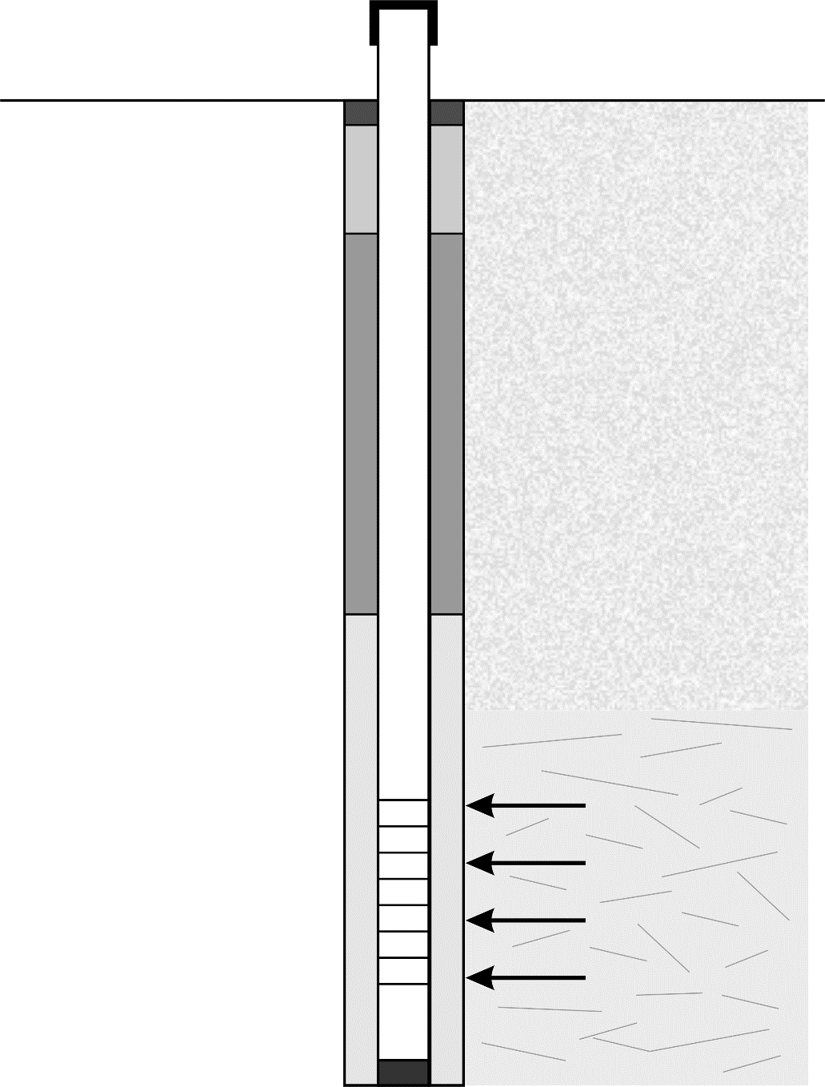

Overburden /  
unstable bedrock

Consolodated formation / stable bedrock

Water bearing zone

**Gravel pack** comprising rounded quartz grain from 1mm to 4mm diameter. Drilling diameter needs to accommodates gravel pack. The thickness of the gravel pack depends on the nature of the formation. A thick (75-100mm) annulus will be required in the case of very fine materials such as mica. Alternatively, it may be possible to use a geotextile filter sock depending on the risk of biofouling.

Rest water level

Impervious clay plug 1m thick

From ground to 0.5m below ground level to be capped with concrete during civil works construction

Gravel Pack / Formation Stabiliser inserted to a minimum of 6m above the screen

*Not to Scale*

**Pump** should be positioned at the correct level above the screened section, taking into account the drawdown and seasonal variations. This is generally at least 2m below the lowest dynamic water level.

**Casing diameter** must accommodate the external diameter of the pump cylinder

**Drilling diameter** to accommodate gravel pack, casing and screen

PVC Screen

Bottom plug / cap

Plain casing for sump (6m)

Backfill to 6m from ground level with drill cuttings

Sanitary seal / grout seal

From 0.5m to 6m below ground level

Ground level

PVC plain casing

Drilling depth depends on the formation. The final drilling depth shall be decided by the supervisor.

Screen position and length shall be decided by the supervisor

*For definitions of gravel pack, filter pack and formation stabilizer see* ***Definitions*** *in the Toolkit Introducion.*

Drawing 2 Sample Well Design (un-consolidated formation to depth of 100-120 m; at greater depths use steel casing)

**Secure cap**

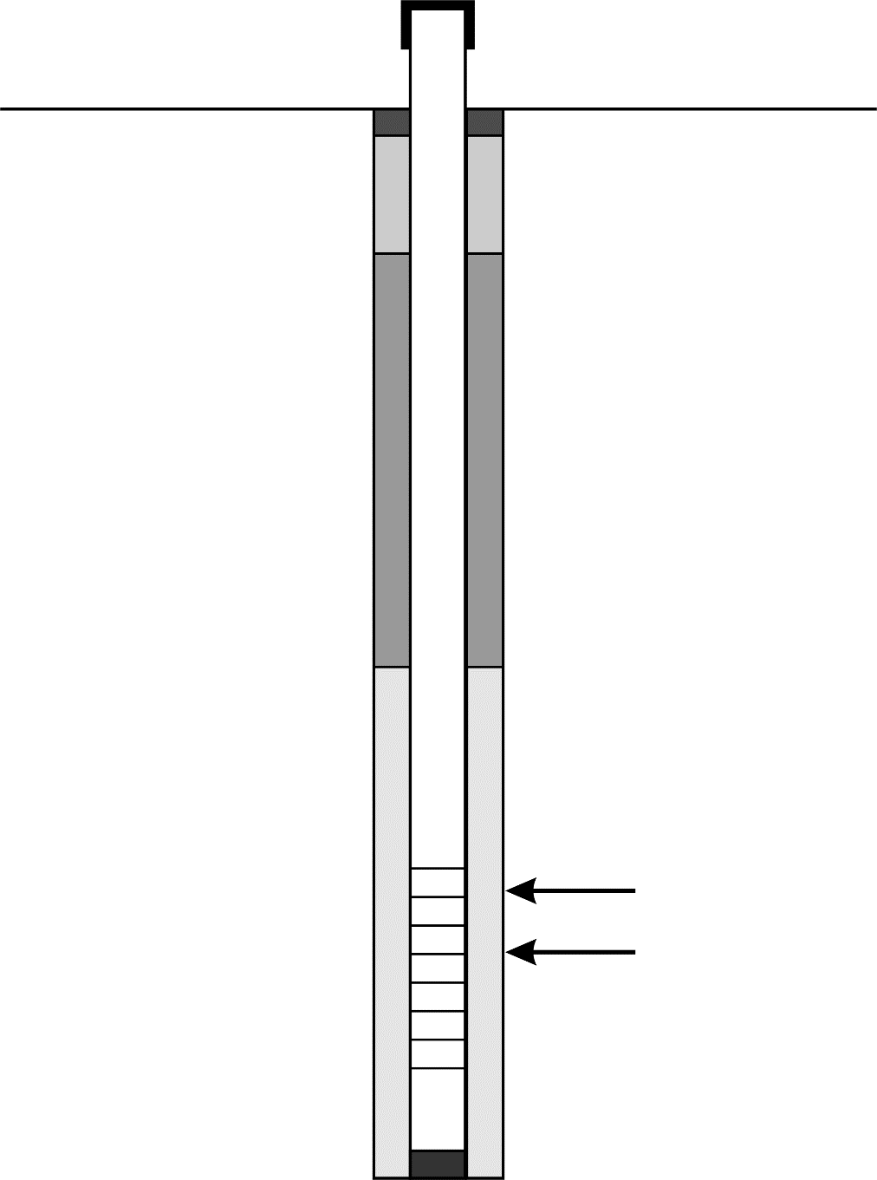

**Gravel pack** comprising rounded quartz grain from 1mm to 4mm diameter. Drilling diameter needs to accommodates gravel pack. The thickness of the gravel pack depends on the nature of the formation. A thick (75-100mm) annulus will be required in the case of very fine materials such as mica. Alternatively, it may be possible to use a geotextile filter sock depending on the risk of biofouling.

Rest water level

Impervious clay plug 1m thick

From ground to 0.5m below ground level to be capped with concrete during civil works construction

Gravel Pack / Formation Stabiliser inserted to a minimum of 6m above the screen

*Not to Scale*

**Pump** should be positioned at the correct level above the screened section, taking into account the drawdown and seasonal variations. This is generally at least 2m below the lowest dynamic water level.

**Casing diameter** must accommodate the external diameter of the pump cylinder

**Drilling diameter** to accommodate gravel pack, casing and screen

Water bearing zone

PVC Screen

Bottom plug / cap

Plain casing for sump (6m)

Backfill to 6m from ground level with drill cuttings

Sanitary seal / grout seal

From 0.5m to 6m below ground level

Ground level

PVC plain casing

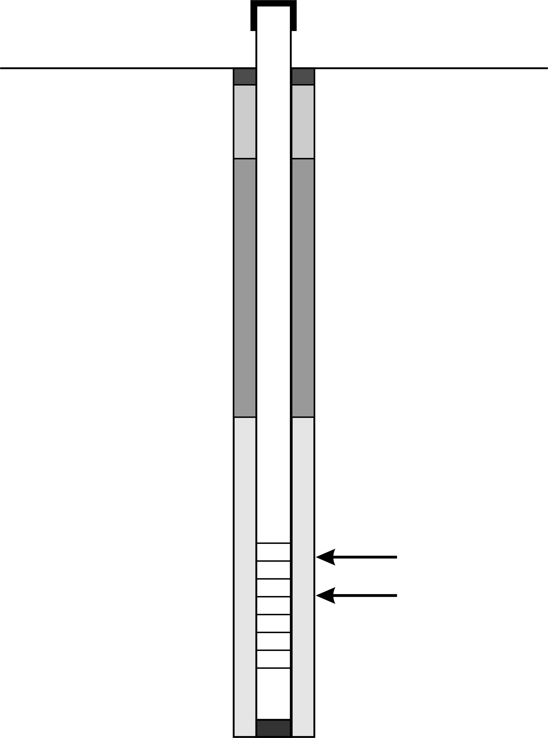

Drilling depth depends on the formation. The final drilling depth shall be decided by the supervisor.

Screen position and length shall be decided by the supervisor

*For definitions of gravel pack, filter pack and formation stabilizer see* ***Definitions*** *in the Toolkit Introducion.*

Drawing 3 Example of Platform Design

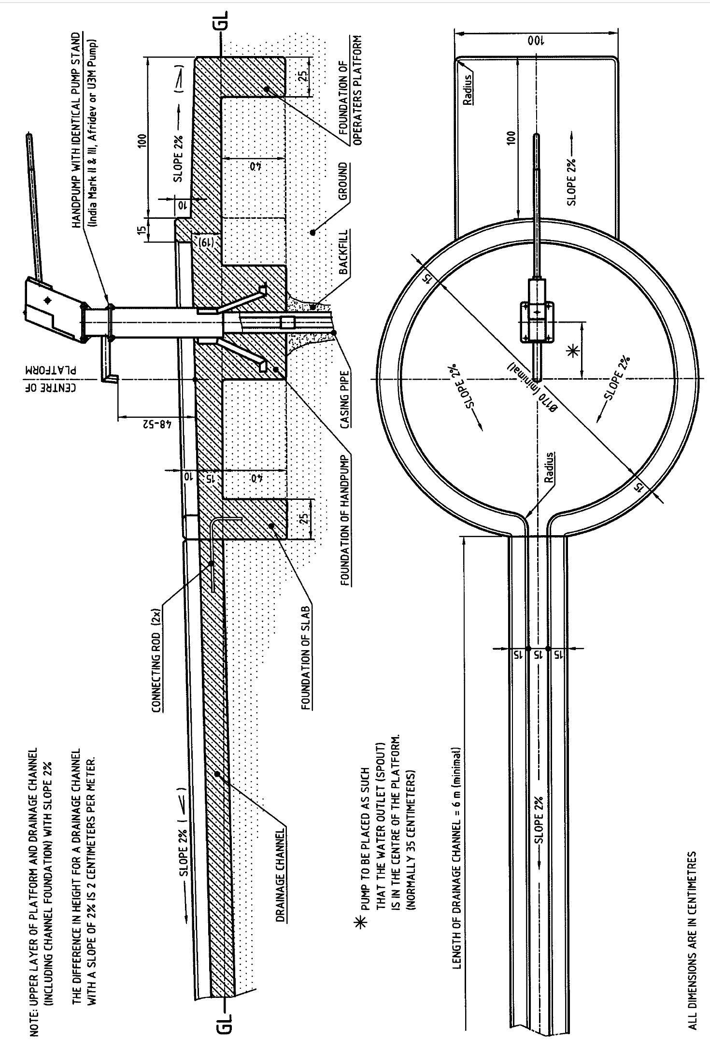

Skat and RWSN (2008) ***Platform Design for Boreholes Construction Guidelines*** (Revision 1-2008) provides further details.

Drawing 4 Soak-Pit

****

Skat and RWSN (2008) ***Platform Design for Boreholes Construction Guidelines*** (Revision 1-2008) provides further details.

Drawing 5 Sample Brass Plaque Design

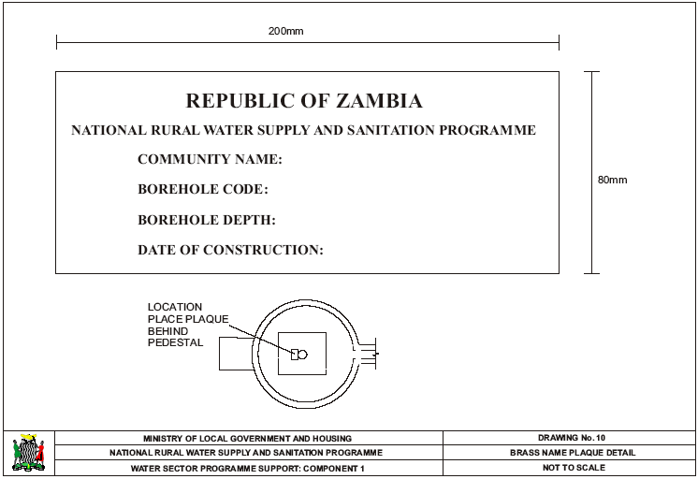

## Annex 4.3 Suggested Format for Borehole Completion Record

**Contents**

1. General
2. Drilling Operation
3. Casing and Well Completion
4. Well Development and Pumping Test Summary
5. Water Quality Summary
6. Lithology

6a. Lithological Logging

6b. Characteristics to be evaluated and assessed during logging of drilling samples

1. Pumping Test Details

7a. Step Drawdown Test

7b. Constant Rate Test

7c. Recovery Test

1. Water Quality Analysis Parameters

|  |  |  |
| --- | --- | --- |
| **1. General** | | |
| **Water Well/Borehole Reference No:** |  | Use: Community Household/Private Compound  Health Facility Education Facility  Company Premises Test Well Other |
| Location: | | Owner Name: |
| Owner Address: |
| Coordinates/  GPS Reference: | Grid Ref:  Long. E Lat. N |
| Financing Programme/Project/Private: | | |
| Well Permit No: | Date Issued: | Issuing Authority: |
| Name of Drilling Enterprise: | | Drilling Contractor’s License No: |
| Address of Drilling Enterprise: | | |
| Sketch Map  *Approximate Scale:* | | |

|  |  |  |  |  |  |  |  |
| --- | --- | --- | --- | --- | --- | --- | --- |
| **2. Drilling Operation** | | | | | | | |
| Start Date: | Total Depth: | | | m | Drilling method(s):  Hand Drilled (specify type) \_\_\_\_\_\_\_\_\_\_\_\_\_\_\_\_\_\_  Percussion Mud Rotary Air Rotary DTH  Combination (details):\_\_\_\_\_\_\_\_\_\_\_\_\_\_\_\_\_\_\_\_\_\_\_  Rig make: \_\_\_\_\_\_\_\_\_\_\_\_\_\_\_\_\_\_\_\_\_\_\_\_\_\_\_\_\_\_\_\_\_\_\_  Compressor make: \_\_\_\_\_\_\_\_\_\_\_\_\_\_\_\_\_\_\_\_\_\_\_\_\_\_\_\_ | | |
| Main Water Strike: | | | m |
| Completion Date: | Static Water Level: | | | m |
| Dynamic Water Level: (when pumping at \_\_\_\_m3/hr) | | | m |
| Average Penetration Rate:\_\_\_\_\_ m/h (at diameter \_\_\_\_mm/inch)  Average Penetration Rate:\_\_\_\_\_ m/h (at diameter \_\_\_\_mm/inch)  Average Penetration Rate:\_\_\_\_\_ m/h (at diameter \_\_\_\_mm/inch)  Average Penetration Rate:\_\_\_\_\_ m/h (at diameter \_\_\_\_mm/inch) | | | | | | | |
| **From** | | **To** | **Drilling Diameter**  inch mm | | | **Method** | **Penetration Rate (m/h)** |
| m | | m |  | | |  |  |
| m | | m |  | | |  |  |
| m | | m |  | | |  |  |
| m | | m |  | | |  |  |
| m | | m |  | | |  |  |
| m | | m |  | | |  |  |
| m | | m |  | | |  |  |
| m | | m |  | | |  |  |
| m | | m |  | | |  |  |
| m | | m |  | | |  |  |
| m | | m |  | | |  |  |
| m | | m |  | | |  |  |
| m | | m |  | | |  |  |
| m | | m |  | | |  |  |
| m | | m |  | | |  |  |
| m | | m |  | | |  |  |
| m | | m |  | | |  |  |
| m | | m |  | | |  |  |
| m | | m |  | | |  |  |
| m | | m |  | | |  |  |
| m | | m |  | | |  |  |
| m | | m |  | | |  |  |
| m | | m |  | | |  |  |
| m | | m |  | | |  |  |
| m | | m |  | | |  |  |
| m | | m |  | | |  |  |
| m | | m |  | | |  |  |
| m | | m |  | | |  |  |

|  |  |  |  |  |  |  |
| --- | --- | --- | --- | --- | --- | --- |
| **3. Casing and Well Completion** | | | | | | |
| Casing Material: \_\_\_\_\_\_\_\_\_\_\_\_\_\_\_\_\_\_\_\_\_  Casing Joints: Threaded Glue and Socket | | | | Screen Open Area (%) \_\_\_\_\_\_  Bottom Plug: Yes No | | |
| **Casing** | | | | | | |
| **From** | **To** | **Diameter**  **inch** **mm** | | | **Type** | |
| m | m |  | | |  | |
| m | m |  | | |  | |
| m | m |  | | |  | |
| m | m |  | | |  | |
| m | m |  | | |  | |
| m | m |  | | |  | |
| **Screen** | | | | | | |
| **From** | **To** | **Diameter**  **inch** **mm** | | | **Type** | **Slot Size** |
| m | m |  | | |  |  |
| m | m |  | | |  |  |
| m | m |  | | |  |  |
| m | m |  | | |  |  |
| m | m |  | | |  |  |
| m | m |  | | |  |  |
| **Gravel** **natural** **artificial** | | | | | | |
| **From** | **To** | **Grain Size** | | | **Volume used** | |
| m | m |  | | |  | |
| m | m |  | | |  | |
| **Backfill and Sanitary Seal** | | | | | | |
| **From** | **To** | **Diameter**  **inch** **mm** | | | **Type and details**  **(Backfill/Sanitary Seal)** | |
|  |  |  | | |  | |
|  |  |  | | |  | |
|  |  |  | | |  | |
|  |  |  | | |  | |
|  |  |  | | |  | |
| **Alignment and Verticality Test Remarks:** | | | | | | |
| **Well head and Platform** | | | | | | |
| **Well Cap:** Yes No | | | | | | |
| **Apron**:  Concrete slab  Drainage  Soak-away pit  Fence | | | **Pump: Pump installed:** Yes No  Stand  Fitted around casing  Welded on casing  Pump Type:\_\_\_\_\_\_\_\_\_\_\_\_\_\_\_\_\_\_\_\_\_\_\_\_\_\_\_\_\_\_\_\_\_\_\_\_ | | | |
| Comments: \_\_\_\_\_\_\_\_\_\_\_\_\_\_\_\_\_\_\_\_\_\_\_\_\_\_\_\_\_\_\_\_\_\_\_\_\_\_\_\_\_\_\_\_\_\_\_\_\_\_\_\_\_\_\_\_\_\_\_\_\_\_\_\_\_\_\_\_\_\_\_\_\_\_\_\_\_\_\_\_\_\_\_\_\_\_\_ | | | | | | |

|  |  |
| --- | --- |
| **4. Well Development and Pumping Test Summary** | |
| **Development**:  Air-lift  Over-pumping  Surging  Backwashing  Jetting  Duration \_\_\_\_\_\_\_\_\_\_\_\_\_hr  Comments: \_\_\_\_\_\_\_\_\_\_\_\_\_\_\_\_\_\_\_\_\_\_\_\_\_\_\_\_\_\_\_\_\_\_  \_\_\_\_\_\_\_\_\_\_\_\_\_\_\_\_\_\_\_\_\_\_\_\_\_\_\_\_\_\_\_\_\_\_\_\_\_\_\_\_\_\_\_\_ | **Pumping Test:**  Air-lift capacity evaluation  Constant Rate Test (CRT)  Step Drawdown Test  Duration \_\_\_\_\_\_\_\_\_hr  Discharge \_\_\_\_\_\_\_\_l/s  Dynamic water level: \_\_\_\_\_\_\_\_\_m  Drawdown: \_\_\_\_\_\_\_\_\_m  Comments: \_\_\_\_\_\_\_\_\_\_\_\_\_\_\_\_\_\_\_\_\_\_\_\_\_\_\_\_\_\_\_\_\_\_\_  \_\_\_\_\_\_\_\_\_\_\_\_\_\_\_\_\_\_\_\_\_\_\_\_\_\_\_\_\_\_\_\_\_\_\_\_\_\_\_\_\_\_\_\_\_ |

|  |  |
| --- | --- |
| **5. Water Quality Summary** | |
| **Sample taken**: 🞏 Yes 🞏 No  Date\_\_\_\_\_\_\_\_\_\_\_\_ | **Chemical Quality**:  pH:\_\_\_\_\_\_\_\_\_\_\_\_\_\_\_  Laboratory: \_\_\_\_\_\_\_\_\_\_  (for more parameters see separate sheet) |
| **Field Parameters**:  🞏 Clear  🞏 Turbid  Colour\_\_\_\_\_\_\_ Taste\_\_\_\_\_\_\_ Odour \_\_\_\_\_\_ Turbidity\_\_\_\_\_\_NTU Temp. \_\_\_\_\_\_˚C TDS\_\_\_\_\_\_mg/l EC\_\_\_\_\_\_\_µS-cm pH \_\_\_\_\_\_ |
| **Bacteriological Quality:**  Faecal coliform: \_\_\_\_\_\_\_\_\_\_\_\_cfu per 100ml  Laboratory: \_\_\_\_\_\_\_\_\_\_\_\_\_\_\_\_\_\_\_\_\_\_\_\_\_\_\_\_\_\_\_ |
| Comments: \_\_\_\_\_\_\_\_\_\_\_\_\_\_\_\_\_\_\_\_\_\_\_\_\_\_\_\_\_\_\_\_\_\_\_\_\_\_\_\_\_\_\_\_\_\_\_\_\_\_\_\_\_\_\_\_\_\_\_\_\_\_\_\_\_\_\_\_\_\_\_\_\_\_\_\_\_\_\_\_\_ | |

|  |  |  |  |  |  |  |  |  |  |  |  |  |  |  |
| --- | --- | --- | --- | --- | --- | --- | --- | --- | --- | --- | --- | --- | --- | --- |
| **6a. Lithological Logging** | | | | | | | | | | | | | | |
| **Water Well/Borehole Reference No:** | | | | |  | | | | |  | | | | |
| Location: | | | | | | | | | | Owner Name: | | | | |
| Owner Address: | | | | |
| Coordinates/ GPS Reference: | | | | | Grid Ref: Long. E Lat. N | | | | |
| Financing Programme/Project/Private: | | | | | | | | | | | | | | |
| Well Permit No. | | | | | Date Issued: | | | | | Issuing Authority | | | | |
| Name of Drilling Enterprise: | | | | | | | | | | Drilling Constractor’s License No: | | | | |
| Well Logged by: | | | | | | | | | | | | | | |
| Depth (m) | Description | Colour\* | Grain size\* | Texture\* | | Degree of  weathering\* | Sorting\* | Roundness | Stratigraphic  unit (if known)\* | Remarks  (e.g. consolidation, porosity, mineralogy, structures and features, drilling, water) | Penetration rate  (min/m) | Discharge | EC (*µS/cm)* | TDS (*mg/l)* |
|  |  |  |  |  | |  |  |  |  |  |  |  |  |  |
|  |  |  |  |  | |  |  |  |  |  |  |  |  |  |
|  |  |  |  |  | |  |  |  |  |  |  |  |  |  |
|  |  |  |  |  | |  |  |  |  |  |  |  |  |  |
|  |  |  |  |  | |  |  |  |  |  |  |  |  |  |
|  |  |  |  |  | |  |  |  |  |  |  |  |  |  |
|  |  |  |  |  | |  |  |  |  |  |  |  |  |  |

Data to be recorded at a minimum of one-metre intervals – add more sheets if required; \* See overleaf for description.

#### 6b. Characteristics to be evaluated and assessed during logging of drilling samples

(Source Misstear et al, 2006; MacDonald et al, 20058F[[9]](#footnote-9))

Standard procedures for sample description such as British Standards Institution (1999) or the American Society for Testing and Materials (2000) should be followed.

|  |
| --- |
| **Colour**  In order to aid objectivity, a definitive colour chart, e.g. Munsel® Colour Chart, may be used for classification. Munsel® colours are referred to by two or three words such as brownish yellow or light bluish grey and a number. |
| **Grain Size**  The visible grains can be compared with a comparator diagram such as the one given below, a grain sample card or the naked eye. A hand lens or microscope may be required to see grains which are not visible to the naked eye.  Figure Grain Size, Sorting and Roundness Chart(Source: University of Wisconsin, 2010)  **C:\data\_skat\01_pbl\2010\10-2-006_fieldnotes\cost-effective-boreholes_v01\img\01\img001_01.jpg** |
| **Texture**  Is the sample compact and dense, or light and friable? Is it granular or plastic? Can it be moulded or rolled? Can the fragment be scratched with a steel blade or fingernail? Moh’s Scale of Hardness is an indicator. |
| **Degree of weathering**  The extent of weathering of rocks affects the availability of groundwater. Essentially, the weathering profile comprises the three basic units of soil, weathered rock and fresh rock. Rock weathering is described in terms of distribution and relative proportions of fresh and discoloured rock, decomposed and disintegrated rock. |
| **Degree of sorting**  Sorting describes the variability of attributes such as rounding and grain size. In well-sorted materials, the component grains are mostly of a similar size, shape and roundness. Sorting can be classified as very well sorted, well sorted, moderately sorted, poorly sorted and very poorly sorted as set out in the grain size and sorting chart above. |
| **Roundness**  Grains are usually classified as angular, sub-angular, sub-rounded, rounded or well-rounded as shown in the chart above. |
| **Formation / Stratigraphic unit (if known, add codes based on the local stratigraphic nomenclature)**  An experienced geologist or driller may be able to identify stratiographic units. However it is important to distinguish between *interpretation* and *observation.* Thus the basic raw data (above) as well as his or her interpretation should be recorded. |

#### 7. Pumping Test Details

|  |  |  |  |  |  |  |  |  |
| --- | --- | --- | --- | --- | --- | --- | --- | --- |
| **7a. Step Drawdown Test (for mechanised borehole supply)** | | | | | | | | |
| **Water Well/Borehole Reference No:** | | | | | **Water Well Name:** | | | |
| **Start Test Date:** | | | | | **Time of Day:** | | | |
| Static Water Level before Test: m | | | Pump Intake: m | | | | |  |
| Date for measurements | | | Pumping Well/ Observation Well (Tick appropriate) | | | | |
| **Time** | | | **Water Level** | | | **Discharge (Q)** | | **Remark** |
| Real Time | Hrs | Min | Depth to Water | Drawdown | | Volumetric Method | Flow Metre | TDS, Temperature, pH and any other observation |
|  |  |  | (m) | (m) | | (l/s or m3/h) | (l/s or m3/h) |
|  |  |  |  |  | |  |  |  |
|  |  |  |  |  | |  |  |  |
|  |  |  |  |  | |  |  |  |
|  |  |  |  |  | |  |  |  |
|  |  |  |  |  | |  |  |  |
|  |  |  |  |  | |  |  |  |
|  |  |  |  |  | |  |  |  |
|  |  |  |  |  | |  |  |  |
|  |  |  |  |  | |  |  |  |
|  |  |  |  |  | |  |  |  |
|  |  |  |  |  | |  |  |  |
|  |  |  |  |  | |  |  |  |
|  |  |  |  |  | |  |  |  |
|  |  |  |  |  | |  |  |  |
|  |  |  |  |  | |  |  |  |
|  |  |  |  |  | |  |  |  |
|  |  |  |  |  | |  |  |  |
|  |  |  |  |  | |  |  |  |
|  |  |  |  |  | |  |  |  |
|  |  |  |  |  | |  |  |  |
|  |  |  |  |  | |  |  |  |
|  |  |  |  |  | |  |  |  |
|  |  |  |  |  | |  |  |  |
|  |  |  |  |  | |  |  |  |
|  |  |  |  |  | |  |  |  |
|  |  |  |  |  | |  |  |  |
|  |  |  |  |  | |  |  |  |
|  |  |  |  |  | |  |  |  |
|  |  |  |  |  | |  |  |  |
|  |  |  |  |  | |  |  |  |
|  |  |  |  |  | |  |  |  |
|  |  |  |  |  | |  |  |  |

|  |  |  |  |  |  |  |  |
| --- | --- | --- | --- | --- | --- | --- | --- |
| **Time** | | | **Water Level** | | **Discharge (Q)** | | **Remark** |
| Real Time | Hrs | Min | Depth to Water | Drawdown | Volumetric Method | Flow Metre | TDS, Temperature, pH and any other observation |
|  |  |  | (m) | (m) | (l/s or m3/h) | (l/s or m3/h) |
|  |  |  |  |  |  |  |  |
|  |  |  |  |  |  |  |  |
|  |  |  |  |  |  |  |  |
|  |  |  |  |  |  |  |  |
|  |  |  |  |  |  |  |  |
|  |  |  |  |  |  |  |  |
|  |  |  |  |  |  |  |  |
|  |  |  |  |  |  |  |  |
|  |  |  |  |  |  |  |  |
|  |  |  |  |  |  |  |  |
|  |  |  |  |  |  |  |  |
|  |  |  |  |  |  |  |  |
|  |  |  |  |  |  |  |  |
|  |  |  |  |  |  |  |  |
|  |  |  |  |  |  |  |  |
|  |  |  |  |  |  |  |  |
|  |  |  |  |  |  |  |  |
|  |  |  |  |  |  |  |  |
|  |  |  |  |  |  |  |  |
|  |  |  |  |  |  |  |  |
|  |  |  |  |  |  |  |  |
|  |  |  |  |  |  |  |  |
|  |  |  |  |  |  |  |  |
|  |  |  |  |  |  |  |  |
|  |  |  |  |  |  |  |  |
|  |  |  |  |  |  |  |  |
|  |  |  |  |  |  |  |  |
|  |  |  |  |  |  |  |  |
|  |  |  |  |  |  |  |  |
|  |  |  |  |  |  |  |  |
|  |  |  |  |  |  |  |  |
|  |  |  |  |  |  |  |  |
|  |  |  |  |  |  |  |  |
|  |  |  |  |  |  |  |  |
|  |  |  |  |  |  |  |  |
|  |  |  |  |  |  |  |  |
|  |  |  |  |  |  |  |  |
|  |  |  |  |  |  |  |  |
|  |  |  |  |  |  |  |  |
|  |  |  |  |  |  |  |  |
|  |  |  |  |  |  |  |  |
|  |  |  |  |  |  |  |  |
|  |  |  |  |  |  |  |  |
|  |  |  |  |  |  |  |  |
|  |  |  |  |  |  |  |  |
|  |  |  |  |  |  |  |  |
|  |  |  |  |  |  |  |  |
| **Time** | | | **Water Level** | | **Discharge (Q)** | | **Remark** |
| Real Time | Hrs | Min | Depth to Water | Drawdown | Volumetric Method | Flow Metre | TDS, Temperature, pH and any other observation |
|  |  |  | (m) | (m) | (l/s or m3/h) | (l/s or m3/h) |
|  |  |  |  |  |  |  |  |
|  |  |  |  |  |  |  |  |
|  |  |  |  |  |  |  |  |
|  |  |  |  |  |  |  |  |
|  |  |  |  |  |  |  |  |
|  |  |  |  |  |  |  |  |
|  |  |  |  |  |  |  |  |
|  |  |  |  |  |  |  |  |
|  |  |  |  |  |  |  |  |
|  |  |  |  |  |  |  |  |
|  |  |  |  |  |  |  |  |
|  |  |  |  |  |  |  |  |
|  |  |  |  |  |  |  |  |
|  |  |  |  |  |  |  |  |
|  |  |  |  |  |  |  |  |
|  |  |  |  |  |  |  |  |
|  |  |  |  |  |  |  |  |
|  |  |  |  |  |  |  |  |
|  |  |  |  |  |  |  |  |
|  |  |  |  |  |  |  |  |
|  |  |  |  |  |  |  |  |
|  |  |  |  |  |  |  |  |
|  |  |  |  |  |  |  |  |
|  |  |  |  |  |  |  |  |
|  |  |  |  |  |  |  |  |
|  |  |  |  |  |  |  |  |
|  |  |  |  |  |  |  |  |
|  |  |  |  |  |  |  |  |
|  |  |  |  |  |  |  |  |
|  |  |  |  |  |  |  |  |
|  |  |  |  |  |  |  |  |
|  |  |  |  |  |  |  |  |
|  |  |  |  |  |  |  |  |
|  |  |  |  |  |  |  |  |
|  |  |  |  |  |  |  |  |
|  |  |  |  |  |  |  |  |
|  |  |  |  |  |  |  |  |
|  |  |  |  |  |  |  |  |
|  |  |  |  |  |  |  |  |
|  |  |  |  |  |  |  |  |
|  |  |  |  |  |  |  |  |
|  |  |  |  |  |  |  |  |
|  |  |  |  |  |  |  |  |
|  |  |  |  |  |  |  |  |
|  |  |  |  |  |  |  |  |

|  |  |  |  |  |  |  |  |  |  |  |  |  |  |  |  |  |  |  |  |  |  |  |  |
| --- | --- | --- | --- | --- | --- | --- | --- | --- | --- | --- | --- | --- | --- | --- | --- | --- | --- | --- | --- | --- | --- | --- | --- |
| **7b. Constant Rate Test (note that 3 to 6 hours is sufficient of a handpump supply)** | | | | | | | | | | | | | | | | | | | | | | | |
| **Water Well/Borehole Reference No:** | | | | | | | | | | | | | **Water Well Name:** | | | | | | | | | | |
| **Start Test Date:** | | | | | | | | | | | | | **Time of Day** | | | | | | | | | | |
| Static Water Level before the Test: m | | | | | | | Data in this table is for:  Pumping Well/ Observation Well (Tick Appropriate) | | | | | | | | | | | | | |  | | |
| Datum for measurements | | | | | | |
| Average Discharge ( l/sec) | | | | | | | Obs. Well No. | | | | | | | Distance (m) | | | | | | | Depth (m) | | |
| **Time** | | | | | | | **Water Level** | | | | | | | **Discharge (Q)** | | | | | | | **Remark** | | |
| Real Time | | | Hrs | | Min | | Depth of Water | | | Drawdown | | | | Container Method | | Flow Metre | | | | | TDS, Temperature, pH and any other observation | | |
|  | | |  | |  | | (m) | | | (m) | | | | (l/s or m3/h) | | (l/s or m3/h) | | | | |
|  | | |  | |  | |  | | |  | | | |  | |  | | | | |  | | |
|  | | |  | |  | |  | | |  | | | |  | |  | | | | |  | | |
|  | | |  | |  | |  | | |  | | | |  | |  | | | | |  | | |
|  | | |  | |  | |  | | |  | | | |  | |  | | | | |  | | |
|  | | |  | |  | |  | | |  | | | |  | |  | | | | |  | | |
|  | | |  | |  | |  | | |  | | | |  | |  | | | | |  | | |
|  | | |  | |  | |  | | |  | | | |  | |  | | | | |  | | |
|  | | |  | |  | |  | | |  | | | |  | |  | | | | |  | | |
|  | | |  | |  | |  | | |  | | | |  | |  | | | | |  | | |
|  | | |  | |  | |  | | |  | | | |  | |  | | | | |  | | |
|  | | |  | |  | |  | | |  | | | |  | |  | | | | |  | | |
|  | | |  | |  | |  | | |  | | | |  | |  | | | | |  | | |
|  | | |  | |  | |  | | |  | | | |  | |  | | | | |  | | |
|  | | |  | |  | |  | | |  | | | |  | |  | | | | |  | | |
|  | | |  | |  | |  | | |  | | | |  | |  | | | | |  | | |
|  | | |  | |  | |  | | |  | | | |  | |  | | | | |  | | |
|  | | |  | |  | |  | | |  | | | |  | |  | | | | |  | | |
|  | | |  | |  | |  | | |  | | | |  | |  | | | | |  | | |
|  | | |  | |  | |  | | |  | | | |  | |  | | | | |  | | |
|  | | |  | |  | |  | | |  | | | |  | |  | | | | |  | | |
|  | | |  | |  | |  | | |  | | | |  | |  | | | | |  | | |
|  | | |  | |  | |  | | |  | | | |  | |  | | | | |  | | |
|  | | |  | |  | |  | | |  | | | |  | |  | | | | |  | | |
|  | | |  | |  | |  | | |  | | | |  | |  | | | | |  | | |
|  | | |  | |  | |  | | |  | | | |  | |  | | | | |  | | |
|  | | |  | |  | |  | | |  | | | |  | |  | | | | |  | | |
|  | | |  | |  | |  | | |  | | | |  | |  | | | | |  | | |
|  | | |  | |  | |  | | |  | | | |  | |  | | | | |  | | |
|  | | |  | |  | |  | | |  | | | |  | |  | | | | |  | | |
|  | | |  | |  | |  | | |  | | | |  | |  | | | | |  | | |
|  | | |  | |  | |  | | |  | | | |  | |  | | | | |  | | |
|  | | |  | |  | |  | | |  | | | |  | |  | | | | |  | | |
|  | | |  | |  | |  | | |  | | | |  | |  | | | | |  | | |
| **Time** | | | | | | | **Water Level** | | | | | | | **Discharge (Q)** | | | | | | | **Remark** | | |
| Real Time | | Hrs | | | Min | | Depth of Water | | | Drawdown **(S)** | | | | Container Method | | Flow Metre | | | | | TDS, Temperature, pH and any other observation | | |
|  | |  | | |  | | (m) | | | (m) | | | | (l/s or m3/h) | | (l/s or m3/h) | | | | |
|  | |  | | |  | |  | | |  | | | |  | |  | | | | |  | | |
|  | |  | | |  | |  | | |  | | | |  | |  | | | | |  | | |
|  | |  | | |  | |  | | |  | | | |  | |  | | | | |  | | |
|  | |  | | |  | |  | | |  | | | |  | |  | | | | |  | | |
|  | |  | | |  | |  | | |  | | | |  | |  | | | | |  | | |
|  | |  | | |  | |  | | |  | | | |  | |  | | | | |  | | |
|  | |  | | |  | |  | | |  | | | |  | |  | | | | |  | | |
|  | |  | | |  | |  | | |  | | | |  | |  | | | | |  | | |
|  | |  | | |  | |  | | |  | | | |  | |  | | | | |  | | |
|  | |  | | |  | |  | | |  | | | |  | |  | | | | |  | | |
|  | |  | | |  | |  | | |  | | | |  | |  | | | | |  | | |
|  | |  | | |  | |  | | |  | | | |  | |  | | | | |  | | |
|  | |  | | |  | |  | | |  | | | |  | |  | | | | |  | | |
|  | |  | | |  | |  | | |  | | | |  | |  | | | | |  | | |
|  | |  | | |  | |  | | |  | | | |  | |  | | | | |  | | |
|  | |  | | |  | |  | | |  | | | |  | |  | | | | |  | | |
|  | |  | | |  | |  | | |  | | | |  | |  | | | | |  | | |
|  | |  | | |  | |  | | |  | | | |  | |  | | | | |  | | |
|  | |  | | |  | |  | | |  | | | |  | |  | | | | |  | | |
|  | |  | | |  | |  | | |  | | | |  | |  | | | | |  | | |
|  | |  | | |  | |  | | |  | | | |  | |  | | | | |  | | |
|  | |  | | |  | |  | | |  | | | |  | |  | | | | |  | | |
|  | |  | | |  | |  | | |  | | | |  | |  | | | | |  | | |
|  | |  | | |  | |  | | |  | | | |  | |  | | | | |  | | |
|  | |  | | |  | |  | | |  | | | |  | |  | | | | |  | | |
|  | |  | | |  | |  | | |  | | | |  | |  | | | | |  | | |
|  | |  | | |  | |  | | |  | | | |  | |  | | | | |  | | |
|  | |  | | |  | |  | | |  | | | |  | |  | | | | |  | | |
|  | |  | | |  | |  | | |  | | | |  | |  | | | | |  | | |
|  | |  | | |  | |  | | |  | | | |  | |  | | | | |  | | |
|  | |  | | |  | |  | | |  | | | |  | |  | | | | |  | | |
|  | |  | | |  | |  | | |  | | | |  | |  | | | | |  | | |
|  | |  | | |  | |  | | |  | | | |  | |  | | | | |  | | |
|  | |  | | |  | |  | | |  | | | |  | |  | | | | |  | | |
|  | |  | | |  | |  | | |  | | | |  | |  | | | | |  | | |
|  | |  | | |  | |  | | |  | | | |  | |  | | | | |  | | |
|  | |  | | |  | |  | | |  | | | |  | |  | | | | |  | | |
|  | |  | | |  | |  | | |  | | | |  | |  | | | | |  | | |
|  | |  | | |  | |  | | |  | | | |  | |  | | | | |  | | |
|  | |  | | |  | |  | | |  | | | |  | |  | | | | |  | | |
|  | |  | | |  | |  | | |  | | | |  | |  | | | | |  | | |
|  | |  | | |  | |  | | |  | | | |  | |  | | | | |  | | |
| **7c Recovery Test** | | | | | | | | | | | | | | | | | | | | | | | |
| **Water Well/Borehole Reference No:** | | | | | | | | | | | | **Water Well Name:** | | | | | | | | | | | |
| **Start Test Date:** | | | | | | | | | | | | **Time of Day:** | | | | | | | | | | | |
| Water Level Before the Test m | | | | | | | | | Pumping Well/ Observation Well (Tick Appropriate) | | | | | | | | | | | | | | |
| Description of pumping test undertaken prior to recovery test: | | | | | | | | | | | | | | | | | | | | | | | |
| Datum for measurements: | | | | | | | | | | | | | | | | | | | | | | | |
| **Time** | | | | | | **Water Level** | | | | | | **Time** | | | | | | | | **Water Level** | | | |
| **Real Time** | **Hours** | | | **Minutes** | | **Depth to Water** | | | **Residual Drawdown** | | | **Real Time** | | | **Hours** | | **Minutes** | | | **Depth of Water** | | **Residual Drawdown** | |
|  |  | | |  | | m | | | m | | |  | | |  | |  | | | m | | m | |
|  |  | | |  | |  | | |  | | |  | | |  | |  | | |  | |  | |
|  |  | | |  | |  | | |  | | |  | | |  | |  | | |  | | |  |
|  |  | | |  | |  | | |  | | |  | | |  | | |  | |  | | |  |
|  |  | | |  | |  | | |  | | |  | | |  | | |  | |  | | |  |
|  |  | | |  | |  | | |  | | |  | | |  | | |  | |  | | |  |
|  |  | | |  | |  | | |  | | |  | | |  | | |  | |  | | |  |
|  |  | | |  | |  | | |  | | |  | | |  | | |  | |  | | |  |
|  |  | | |  | |  | | |  | | |  | | |  | | |  | |  | | |  |
|  |  | | |  | |  | | |  | | |  | | |  | | |  | |  | | |  |
|  |  | | |  | |  | | |  | | |  | | |  | | |  | |  | | |  |
|  |  | | |  | |  | | |  | | |  | | |  | | |  | |  | | |  |
|  |  | | |  | |  | | |  | | |  | | |  | | |  | |  | | |  |
|  |  | | |  | |  | | |  | | |  | | |  | | |  | |  | | |  |
|  |  | | |  | |  | | |  | | |  | | |  | | |  | |  | | |  |
|  |  | | |  | |  | | |  | | |  | | |  | | |  | |  | | |  |
|  |  | | |  | |  | | |  | | |  | | |  | | |  | |  | | |  |
|  |  | | |  | |  | | |  | | |  | | |  | | |  | |  | | |  |
|  |  | | |  | |  | | |  | | |  | | |  | | |  | |  | | |  |
|  |  | | |  | |  | | |  | | |  | | |  | | |  | |  | | |  |
|  |  | | |  | |  | | |  | | |  | | |  | | |  | |  | | |  |
|  |  | | |  | |  | | |  | | |  | | |  | | |  | |  | | |  |
|  |  | | |  | |  | | |  | | |  | | |  | | |  | |  | | |  |
|  |  | | |  | |  | | |  | | |  | | |  | | |  | |  | | |  |
|  |  | | |  | |  | | |  | | |  | | |  | | |  | |  | | |  |
|  |  | | |  | |  | | |  | | |  | | |  | | |  | |  | | |  |
|  |  | | |  | |  | | |  | | |  | | |  | | |  | |  | | |  |
|  |  | | |  | |  | | |  | | |  | | |  | | |  | |  | | |  |
|  |  | | |  | |  | | |  | | |  | | |  | | |  | |  | | |  |
|  |  | | |  | |  | | |  | | |  | | |  | | |  | |  | | |  |
|  |  | | |  | |  | | |  | | |  | | |  | | |  | |  | | |  |
|  |  | | |  | |  | | |  | | |  | | |  | | |  | |  | | |  |
|  |  | | |  | |  | | |  | | |  | | |  | | |  | |  | | |  |
|  |  | | |  | |  | | |  | | |  | | |  | | |  | |  | | |  |
|  |  | | |  | |  | | |  | | |  | | |  | | |  | |  | | |  |
|  |  | | |  | |  | | |  | | |  | | |  | | |  | |  | | |  |
|  |  | | |  | |  | | |  | | |  | | |  | | |  | |  | | |  |
|  |  | | |  | |  | | |  | | |  | | |  | | |  | |  | | |  |
|  |  | | |  | |  | | |  | | |  | | |  | | |  | |  | | |  |
|  |  | | |  | |  | | |  | | |  | | |  | | |  | |  | | |  |
|  |  | | |  | |  | | |  | | |  | | |  | | |  | |  | | |  |
|  |  | | |  | |  | | |  | | |  | | |  | | |  | |  | | |  |
|  |  | | |  | |  | | |  | | |  | | |  | | |  | |  | | |  |
| **8. Water Quality Analysis (critical/regular parameters – amend as required)\*** | | | | | | | | | | | | | | | | | | | | | | | |
| **Water Well/Borehole Reference No:** | | | | | | | | | | | | | | | | | | | **Maximum Permitted Level  According to  National Standards/Guidelines or WHO Guidelines (WHO 2008)** | | | | |
| **Constituents** | | | | | | | | **Unit** | | | **Concentration** | | | | | | | |
| **PHYSICAL** | | | | | | | |  | | |  | | | | | | | |  | | | | |
| Colour | | | | | | | | *mg/l Pt (TCU)* | | |  | | | | | | | |  | | | | |
| Odour | | | | | | | |  | | |  | | | | | | | |  | | | | |
| Taste | | | | | | | |  | | |  | | | | | | | |  | | | | |
| Temperature | | | | | | | | *˚Celcius* | | |  | | | | | | | |  | | | | |
| Turbidity | | | | | | | | *FTU* | | |  | | | | | | | |  | | | | |
| Electrical conductivity | | | | | | | | *µS/cm* | | |  | | | | | | | |  | | | | |
| **CHEMICAL** | | | | | | | |  | | |  | | | | | | | |  | | | | |
| Arsenic (As) | | | | | | | | *µg/l* | | |  | | | | | | | |  | | | | |
| Calcium (Ca2+) | | | | | | | | *mg/l* | | |  | | | | | | | |  | | | | |
| Chloride (Cl-) | | | | | | | | *mg/l* | | |  | | | | | | | |  | | | | |
| Fluoride (F-) | | | | | | | | *mg/l* | | |  | | | | | | | |  | | | | |
| Iron (Fe2+) | | | | | | | | *mg/l* | | |  | | | | | | | |  | | | | |
| Iron (Fe3+) | | | | | | | | *mg/l* | | |  | | | | | | | |  | | | | |
| Magnesium (Mg2+) | | | | | | | | *mg/l* | | |  | | | | | | | |  | | | | |
| Manganese (Mn) | | | | | | | | *mg/l* | | |  | | | | | | | |  | | | | |
| Nitrate (No3-) | | | | | | | | *mg/l* | | |  | | | | | | | |  | | | | |
| Nitrite (No2-) | | | | | | | | *mg/l* | | |  | | | | | | | |  | | | | |
| pH | | | | | | | |  | | |  | | | | | | | |  | | | | |
| Potassium (K+) | | | | | | | | *mg/l* | | |  | | | | | | | |  | | | | |
| Sodium (Na+) | | | | | | | | *mg/l* | | |  | | | | | | | |  | | | | |
| Sulphate (SO4 2-) | | | | | | | | *mg/l* | | |  | | | | | | | |  | | | | |
| Total Dissolved Solids | | | | | | | | *mg/l* | | |  | | | | | | | |  | | | | |
| **Microbiological** | | | | | | | |  | | |  | | | | | | | |  | | | | |
| Thermo-tolerant Coliform (E. Coli) | | | | | | | | *Count/100ml* | | |  | | | | | | | |  | | | | |
| Faecal Coliform | | | | | | | | *Count/100ml* | | |  | | | | | | | |  | | | | |
| Total Coliform Count | | | | | | | | *Count/100ml* | | |  | | | | | | | |  | | | | |

\* Refer to National Standards/Guidelines for Drinking Water Quality or WHO Guidelines (WHO 2008) for list of general parameters.

## Annex 4.4 Pumping Methods - Handpumps

Pumping principles

Any one of the following mechanical principles can lift water. Pumps may use one or sometimes a combination of these principles:

**Direct lift:** Water is physically lifted in a container. Typical examples are: Rope and Bucket, Bailer, Persian Wheel.

**Displacement:** Because water cannot be compressed it can be pushed or displaced. Typical examples are: Piston Pumps, Progressive Cavity Pumps and Diaphragm Pumps.

**Creating a velocity head:** Water can be propelled to a high speed. The momentum produced can be used either to create a pressure or a flow. Typical examples are: Propeller Pumps, Centrifugal Pumps, Rebound Inertia Pumps, Jet Pumps.

**Using the buoyancy of a gas:** Air that is blown into water bubbles upward. It will lift a proportion of the water that it flows through. Typical examples are: Air lift.

**Gravity:** Energy of a media (water) that flows downward under gravity is used to lift water. Typical examples are: Siphons.

Most handpumps use the water displacement principle for pumping.

Reciprocating handpumps

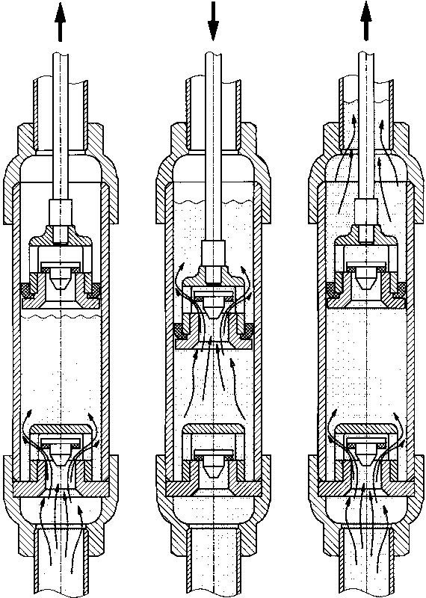The majority of handpump types used worldwide belong to the group of reciprocating pumps. The water is lifted by a piston that is raised and lowered inside a cylinder that has a foot valve. The piston (or plunger) is moved by a pump rod connected directly to a T-handle or a lever handle at the pump head. In some pump types, a flywheel with crankshaft is used to create the reciprocating movement of the piston.

Included in the group of reciprocating handpumps are:

1. Suction Pumps
2. Direct Action Pumps
3. Lever Action Pumps

The function of the reciprocating pumps is based on the principle that water flows from areas of high pressure to areas of low pressure. The reciprocating pump creates an area of sufficiently low pressure above the body of water, thus causing it to flow upward.

A reciprocating piston pump consists essentially of a long vertical pipe, called a rising main. The rising main extends into the cylinder (the area in which the piston/plunger moves up and down). Near the bottom of the cylinder, a non-return valve is fitted, called a foot valve. The foot valve allows the water to flow from the lower part of the pump into the cylinder, but prevents it from flowing back into the well. A second non-return valve is situated in the piston/plunger. The piston/plunger and the foot valve alternatively divide the pump into an upper part and a lower part (see Figure 3.1). The lower part of the pump always extends into water body of the well.

Figure A4.1 Reciprocating Handpump Cylinder

When the operator lowers the piston, the atmospheric pressure acts equally on all water surfaces. The foot valve stays closed, preventing water from being pushed back into the well. The piston presses down onto the water until the non-return piston valve opens, allowing water to flow through the piston. At the lowest point of the stroke, the movement of the piston is reversed. The weight of the water column above the piston causes the piston valve to close. This results in two things:

1. The water above the piston starts rising. It cannot flow backwards and will move up in the rising main until it reaches the top of the pump, flowing out by the spout.
2. Because the piston moves up, the pressure in the lower part of the cylinder drops; a vacuum is created. The water in the well is still under atmospheric pressure and will push its way past the foot valve into the cylinder.

This cycle is repeated with every stroke.

Suction pumps

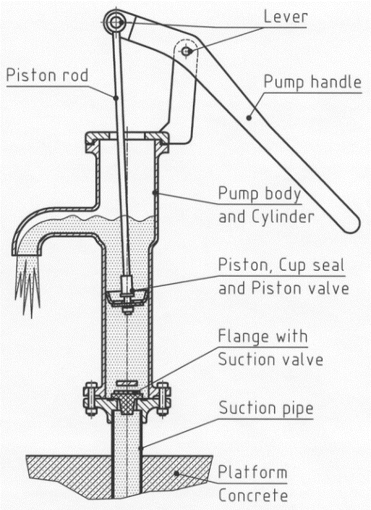In a suction pump, the cylinder is above the water table, usually near the top of the pump head. The rising main extends below the water table. When the pump is operated, during the upwards stroke it appears that water gets ‘sucked up’ through the rising main into the cylinder.

In fact, the atmospheric pressure forces the water into the area of low pressure underneath the piston. The theoretical limit to which the atmospheric pressure can push up water is 10 metres. In practice, suction pumps can be used to lift water up to about 7 or 8 metres.

A suction pump needs to be full of water before it can be operated. That means the pump needs to be primed: water is poured into the pump head by the operator. This is necessary every time the pump is emptied by a leaking foot valve (in practice all foot valves leak a little, especially in inexpensive suction pumps – so the pump may need to be primed every morning, or even several times a day). Thus, the danger exists that the well can be contaminated through polluted water used for priming.

Figure A4.2 Suction pump

The advantage of suction pumps is that the cylinder is normally above ground, and thus easily accessible. Maintenance involves replacement of seals and valves, operations that can be easily performed with few tools.

Direct action pumps

In most direct action handpump designs, the up-and-down movement of the piston is made by a T-handle directly connected to the upper end of the pump rod (hence the name).

The pump rod consists of plastic pipes, which are connected by threads, and each pipe length is sealed airtight. With this system, the pump rod pipes are buoyant in the water of the rising main and therefore reduce the force needed on the up-stroke. Because of the relatively large volume of the hollow pump rods and the narrow clearance in the annulus between the pump rod and rising main (6 to 10 mm); the pump rod displaces water during the down-stroke. This results in the delivery of water during both the up-stroke and the down-stroke.

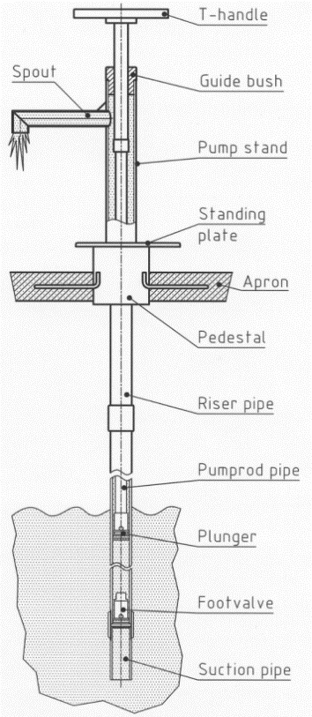Unlike suction pumps, direct action pumps have down-the-hole components that need to be accessed periodically for maintenance and repair. However, these operations are relatively easy for direct action pumps. Once the riser pipes and pump rod pipes are connected, disconnection for maintenance is not required because these pipes are flexible enough to be pulled from the well or borehole in a continuous length without undoing the joints. This operation allows access to the down-the-hole components.

The down-the-hole components are made mainly of plastic (with a few rubber parts). This makes handling and installation of the pump easy (lightweight). It also means the pump is highly corrosion-resistant, even in aggressive waters.

Figure A4.3 Direct action pump

Lever action pumps

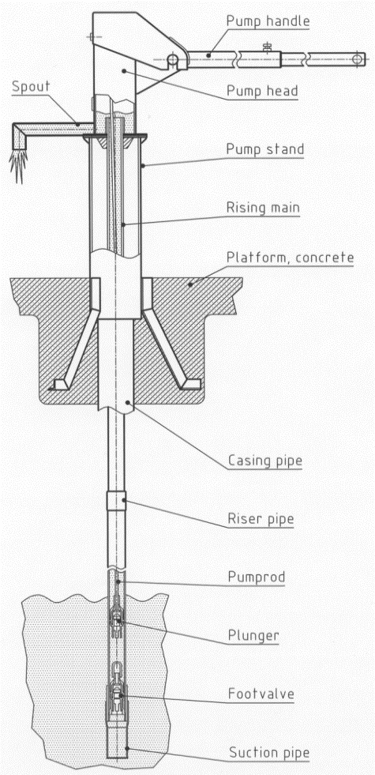Most deep well handpumps are of the lever action type. The increased length of the water column in deep boreholes requires more effort to draw water and the lever of the handle makes the operation easier. Besides the conventional handle, there are also pump designs, which use a flywheel to operate a crankshaft for transforming the rotation into an up-and-down movement.

Lever action pumps consist of

1. above-ground components like pump head, pump stand and handle, which are usually of welded mild steel components, preferably with a corrosion protection of hot-dip-galvanised zinc layer
2. down-the-hole components like rising main, pump rods with plunger, cylinder and foot valve.

The configuration of the down-the-hole components can include an open-top cylinder. The plunger and the foot valve can be removed from the cylinder without dismantling the rising main. Or they can feature the conventional configuration with a small diameter rising main and a bigger cylinder diameter, which requires dismantling of the rising main for repairs on plunger or foot valve.

Riser pipes are made of galvanised iron (GI) pipes, uPVC (unplasticised polyvinyl chloride) or stainless steel.

Pump rods are made of mild steel, stainless steel or fibre reinforced plastic rods (FRP).

Figure A4.4 Lever action pump

Joining of pump rods is preferably made with threaded connections.

Some pump components such as the plunger and foot valve are made of brass or engineered plastics.

Rotary pumps

The most commonly used rotary handpumps are the rope pump and the progressive cavity pump. Note that although some reciprocating pumps use a circular action mechanism to drive the pistons, they are not categorised as rotary.

Rope pump

The rope pump is based on the principle of the ancient Chinese water-lifting technology, the Chain and Washer Pump. The development of this easy, cost-effective and successful technology for water lifting took place mainly in Nicaragua.

The rope pump is not defined by a specific design but by a concept. Worldwide many different rope pump designs, adapted to their local conditions, are produced locally in small workshops near to the users. The producers need to study the potential market and economic viability carefully. Areas with a high density of dug wells usually have a big potential for rope pumps.

|  |  |
| --- | --- |
| Rope01 | Rope22 |
| Figure A4.5 The rope pump principle | Figure A4.6 Rope pump installation |

Rope pumps, being mainly family pumps, require an adapted procurement and supply mechanism. The users themselves should select and purchase their handpumps and take over full ownership. Marketing of the product and its application (they are used for small-scale irrigation as well as for domestic water supply) should be left to the producer and the producer’s sales organization. The rope pump should be sold directly to the users.

A rope loop with attached pistons, equally spaced, is pulled through a pipe, which is immersed in water at its lower end. The pistons entering the rising main pipe transport the water upwards until it reaches the spout through which it escapes.

A pulley wheel (made of a car tire) pulls the rope with the pistons through the rising main pipe. The pulley wheel is operated by a crank handle, which also acts as the wheel axle. A guide near the bottom of the well leads the rope with the pistons smoothly into the rising main.

Hand-operated rope pumps are mostly used for drawing water from dug wells with depths of 0 to 20 metres. However, this pump can also be installed on boreholes (0 to 40 m depth), provided there is an attachment for leading the rope into the borehole and a smaller guide that fits into the borehole casing.

The simplicity of this low-cost pump makes it easy to understand by everyone. It is also easy to maintain and repair with a few simple tools.

Progressive cavity pumps

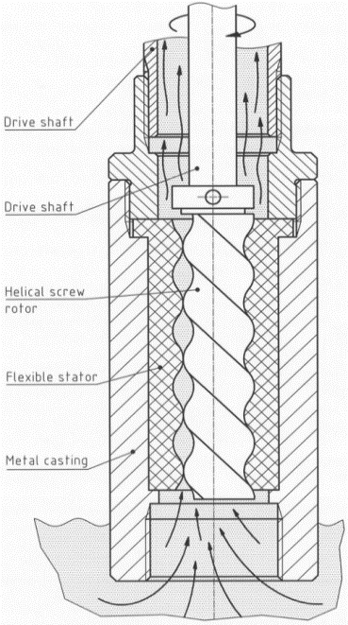Unlike most rotary pumps, progressive cavity pumps can be used in small diameter boreholes.

The progressive cavity pump consists of a single helix rotor. The rotor is made to a high finish, using chromium plated steel or polished stainless steel (SS). It is circular in cross section so that it fits exactly into one of the two helices of the hard rubber stator (the stationary part of a rotor system).

As a result, the empty second helix of the stator is divided into a number of separated voids. When the rotor is turned, these voids are screwed along the axis of rotation. In the well, water will be trapped in the voids and when the rotor is rotated these volumes are pushed upwards and discharged into the rising main.

Progressive cavity pumps need to be driven at a relatively high speed; therefore, handpumps are often fitted with a gearbox. This makes this type of pump relatively complicated and costly.

Figure A4.7 Progressive cavity pump

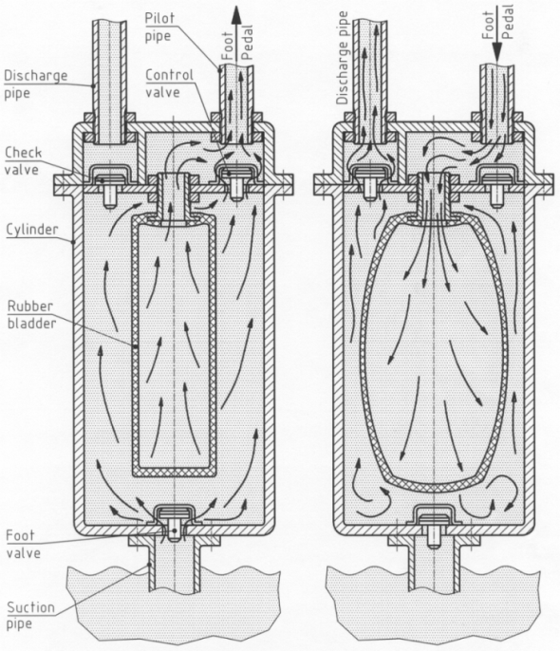Diaphragm pumps

Diaphragm pumps are pumps employing a flexible diaphragm that is expanded and contracted to displace water. The advantages of diaphragm pumps are that they are easy to install, because no heavy mechanical parts are used. They can also be made corrosion-resistant through the use of plastic hoses instead of metallic rising mains.

The disadvantages are that diaphragm pumps need high-quality rubber diaphragms, which are costly to buy and replace, and they have a relatively low efficiency because of the energy needed to expand the diaphragm on every stroke. In addition, the working principle is relatively complex so mechanics and caretakers need to complete comprehensive training programmes.

Figure A4.8 Diaphragm pump

## Annex 4.5 Guideline for Quality Assurance of Handpumps and Spare Parts

#### A4.5.1 Introduction

This Annex helps to optimize the process of hand pump inspectionsand testing to guide country offices in decision making when choosing a type of inspection and/or testing. The main aspects of handpumps and spare parts that this Annex seeks to help evaluate are the quality of the product, quality assurance procedure employed by the company and the performance history of the company or product.

The Annex provides criteria to categorize handpumps into high risk or low risk and evaluate technical performance of handpumps and spare parts performance. Criteria for inspection, product and supplier are defined and specific information about applicability of the criteria provided.

The Annex also provides information related to handpumps, to assess current in country quality assurance (QA) mechanisms to contribute to adequate QA systems and support governments and other development partners to ensure good-quality handpumps. This Annex aims to assist country offices in the preparation, choosing and managing of quality inspections and testing. A description of country office responsibilities and elements that should be reviewed in the evaluation and approval process for quality assurance inspection and/or testing agencies is presented.

It is imperative that this guideline be used together with the latest version of the document: Procurement Strategy: Hand Pumps & Accessories (UNICEF, Water, Sanitation & Education Centre - WSEC).

#### A4.5.2 Risk-Based Categorization of Hand Pumps and Spare Parts

Country Offices are advised to use risk assessment process to determine and classify the level of risk on handpump spare parts to be procured in order to optimize cost and efforts. Based on the classification, relative to the risk of damage or defects, different actions may be pursued and/or recommended. UNICEF Country Offices should review the risk level assessments on quality and technical analysis and formulate the measures required to mitigate the risks identified.

Country offices should categorise handpumps and spare parts from manufactures/traders/retailers into either high risk or low risk as set out below.

Hand pumps and spare parts are categorized as **high risk** if the following criteria are met:

Unsatisfactory test and inspection reports

Lack of availability of spare parts

Problems with the quality, availability and distribution

High probability of being operated beyond the design parameters

The supplier is new and fully matches the criteria for low risk

Technical/desk evaluation cannot fully determine suitability

Low performance evaluation score as per rating criteria (see A4.5.3)

A handpump’s risk for damages or defects is categorized as **low risk** if the product and/or spare parts does meet, at least one of the following criteria:

Warranties from a reputable supplier.

Current/Previous Long Term Agreement (LTA) holders with a good quality track record

Satisfactory test and inspection reports

High Performance evaluation score as per rating criteria (see A4.5.3)

Country offices should review information on the criteria listed above for each vendor and/or product periodically evaluated and change/adjust the risk categorisation/classification for the product(s)/supplier(s) if required.

#### A4.5.3 Handpump Performance Evaluation

Irrespective of whether handpumps and spare parts are classified as high risk or low risk, Country Offices should evaluate handpumps and spare parts performance against the following criteria:

Data Source: Specialized Technical Laboratory with good performance in field trials, product testing, certification and warranty for hand pumps and spare parts.

Reliability: Indication of functionality of the hand pumps and spare parts based on a combined judgement of the mean time before failure (MTBF) and the probable down time when the pump is waiting to be repaired.

Corrosion resistance: Type and corrosive property of materials used for the downhole components.

Abrasion resistance: Pump’s capability to pump water with a lot of sand in relation to the daily output of the pump.

Manufacturing and maintenance needs: ease of manufacturing of handpumps and spare parts and maintenance of hand-pumps and spare parts in a countries with a low level of industrial development

#### A4.5.4 Inspection and Testing 1: Pre-qualification inspection and testing

###### Supplier Quality System

Together with the site inspection and product testing, country offices shall carry out quality audit for manufacturers to get information to evaluate their quality assurance and management system.

The UNICEF Supplier Quality System Questionnaire (See Annex of UNICEF Procurement Strategy: Hand Pumps & Accessories should be used for getting information from an existing or a potential supplier to evaluate their quality and code of conduct processes to decide if they are capable to be a supplier for UNICEF. The questionnaire does not cover product-specific questions such as design, manufacturing, quality, or performance characteristics. Product/process specific topics must be addressed as needed by technically competent auditors.

###### Site Inspection

The purpose of site inspection is primarily to assess the capacity of the manufacture, trader and retailer, in terms of capability and available infrastructure to meet UNICEF’s quality and technical requirements. The premises of manufactures, traders, agents and importers should be inspected, and the inspection would include, but not be limited to, the following:

Report any damage(s) and/or non-optimum aspects observed.

The general information about the manufacturing plant/the trader and retailer shop and its capacity to consistently meet requirement of the specified product in terms of quantity, quality and time.

Information about workers, including qualifications of key staff.

Verification of licenses, lay-out, working environment, safety, ventilation and pollution control system and quality control system .

Manufacturing processes, plant and equipment, machinery and the production infrastructure.

Laboratory, inspection tools and testing equipment.

Handling and storage facilities/ warehousing of raw materials and semi-finished products.

Packing and shipping departments.

Non-employment of child labour in any area of operation and no connection with production of anti-personnel land mines.

The following is the recommended mode of offer of complete handpumps (in sets) that potential suppliers are supposed to adhere to:

Head with handle – On racks (preferably bolted on the racks)

Pedestal – In rows on floor with accessibility between the rows

Water Tanks – On racks or loosely fitted on Pedestals

Third Plate – On racks or loosely fitted on water tanks placed on Pedestals

Cylinder Assembly – On racks in horizontal conditions

Connecting Rods – In bundles or in loose conditions on racks

Riser pipes – In bundles or in loose conditions on racks

Unless otherwise specified in the expression of interest, key components such as head with handle assembly, cylinder assembly, water tank with accessories, connecting rods and riser pipes is/should be individually covered with polythene, over-wrapped with tar coated (note that tar coated is not in the guidelines of Indian Standards anymore. It was replaced by straw ropes with hessian cloth/or HDPE bag) and finally packed in wooden boxes.

###### Product Testing

The purpose of product testing is primarily to carry out sample evaluations and test the range of handpumps and spare parts of products manufactured by suppliers. Handpumps and spare parts from traders/retailers shall only be tested based on one or more of the following:

The trader/retailer does not provide the requested test certificates for the product.

The impact on the quality of the product cannot be determined by the lack of certificates.

There is suspicion on the authenticity of the certificate.

Any other justified technical reasons.

Among the tests and checks normally to be performed are the following:

Check items manufactured against specifications/certificates.

Visual examination of items for quality of workmanship and finish.

Dimensional checks on randomly selected samples.

Fitting, alignment and stroke length of pump assemblies.

Gauge checks on threaded and machined components.

Proper fitting of bearings in the handle assemblies.

Concentricity of side axle bushes in the pump assemblies.

Verticality of water tank coupler.

Discharge capacity, leakage test and interchangeability of components in cylinders.

Shore hardness test on rubber components.

Coating thickness of the galvanized / electro galvanized surfaces.

Marking and labels / components and packaging.

Appearance, product instruction and assembly guides.

###### General Inspection and Testing Requirements

The following are the recommended inspection and testing requirements:

All the galvanized components should be offered / pre-displayed in a way enabling visual examination of all units.

Head assemblies should to be bolted at the flanges (preferably at elevated racks) for verification of the alignment & lateral play (if any) in the handle assembly fitment.

All cylinder assemblies are to be offered in horizontal position, placed in racks, enabling visual examination of inside surface of the brass liner.

Sufficient accessibility is to be provided to all the offered / displayed sub-assemblies.

An inspector will draw random samples (as per the specified sampling plan) for conducting visual, dimensional / gauge checks, zinc coating thickness & shore hardness (on rubber parts) checks.

As per the specified sampling plan (BIS/ ISO 2859-1 or IS-2500 Part 1, General Inspection Level – III), the supplier shall offer the specified number of handpumps in assembled condition for alignment, fitting , interchangeability and stroke length checks.

Randomly drawn samples by the inspector will be subsequently assembled for interchangeability, fitting and alignment checks.

The supplier is to have test facilities for conducting discharge test on cylinder assemblies.

For conducting the leakage test, one length of appropriate size riser pipe is to be made available by the supplier with suitable testing arrangements.

Random samples of gun-metal components, brass liner, and stainless steel components should be drawn by the inspector and taken along for testing.

All check gauges and measuring instruments (duly calibrated with date of calibration and next due date of calibration) should be made available during the course of inspection.

###### Inspection and Testing Expected Outcomes

The following are the expected site inspection and testing outcomes:

###### *Site Inspection expected outcomes*

Depending on the outcome of various checks and tests conducted during the inspection, an inspection note providing “Summary of Inspection and Findings” or an Inspection Non-acceptance Note providing the “Non-conformance Noted” and the supplier’s proposed actions are to be issued to the supplier.

For non-conformities (if any) observed during the course of inspection, if the supplier is able to take corrective actions and subsequently offer the same to the inspector, the materials would be considered for re-verification in the same visit.

Completed audit report based on feedback with scoring shared with suppliers. The supplier should be advised of any non-conformance and containment should be addressed if there are issues concerning the production of non-conforming items.

A summarised audit form comprising supplier strengths, supplier major and minor non-conformances, supplier opportunities for improvement, products rejected, approved or not covered during the audit.

###### *Product Testing expected outcomes*

In case materials are found to be satisfactory, an Interim Inspection Note shall be issued pending the receipt of satisfactory test results obtained from an independent test laboratory, after which the final inspection report should be issued.

If however, the laboratory test results are found not to be meeting the requirements, an Inspection Non-acceptance report shall be issued.

For non-conformities which cannot be corrected during site inspection, the materials should be REJECTED, and the supplier would have to re-offer the materials on a later date for inspection and laboratory testing after taking suitable corrective actions. The Inspection Non-acceptance report should be shared with the supplier, indicating the deviations on which the product has not been accepted.

###### Documentation

It is important that country offices request the following quality documentation from suppliers and/or ensure the supplier furnish the following documents before inspection:

Test certificates for all raw materials / bought out components detailing the chemical composition & physical / mechanical test

Test certificates from an independent test laboratory that is nationally or internationally accredited for testing samples for both chemical analysis and physical / mechanical properties as per the specified requirements

Internal test and inspection records and quality management system documentation

Calibration certificates / records of all measuring instruments and gauges

Proposed packing method

Certificate of conformity

Other special requirements or documents requested during the pre-qualification

At the completion of inspection and testing for pre-qualification, a comprehensive site inspection and testing report of findings and recommendation, with relevant photographs, will be issued and submitted to UNICEF. The report should cover findings (e.g. reasons, inspections, test, certification, Quality Management System) conclusion and recommendations.

#### A4.5.5 Inspection and Testing 2: Pre-delivery and post-delivery inspection and sample evaluation

The purpose of pre-delivery inspection (conducted at manufacturer/trader/retailer’s premise) and gods receipt inspections (conducted at country office warehouses) is to identify non-conformities or defects, so that preventive and corrective action is taken to eliminate and/or avoid deficient supplies reaching consignees.

###### Pre-delivery inspections

Pre-delivery and goods receipt inspections will cover checking of products in accordance with purchase order specifications, proper packing, marking and documentation check and fumigation of pallets, and will include all such tests necessary to verify various requirements required. It is recommended that all purchase orders for handpumps and spare parts are subjected to pre-delivery and goods receipt inspections. Pre-Delivery Inspection should include, but is not limited to, the following functions:

Check quality of the consignment, with samples drawn based on the batch size and sampling plan as per BIS/ ISO 2859-1: latest, or as agreed by country office.

Check items and equipment against the contract specification, technical drawings and other relevant documents and standards.

Check the dimension, workmanship and finish of the items/ equipment.

Verify manufacturers’ test reports for raw materials, or if required, witness the testing of the raw materials.

Check packing, pallet size, and shipping marks against instructions specified in the purchase order, and also verify the quantity of supplies ready in all respects for shipment.

Collect and forward samples for further laboratory testing if required.

Report any damage(s) and/or non-optimum aspects observed.

Any other inspection requirement in the purchase order.

The inspection agency should issue a Certificate of Inspection along with an Inspection Report and provide the country office with relevant photographs for each consignment, within two (2) working days after each inspection, in order to prevent delay in delivery. In the event of an abortive inspection, the inspection agency should submit details of non-conformities in relation to purchase order requirements, with noted deficiencies duly acknowledged (signed and stamped) by the authorised representative of the supplier. The normal, single sampling plan as per BIS/ISO 2859 or IS-2500 Part 1, General Inspection Level – III) should be followed.

For major defects, AQL 1.0 and for Minor defects, AQL 2.5 will be followed unless specified otherwise. Consignments with critical defects should be rejected. However, it is the responsibility of country offices to release consignment for shipment. Inspections against different purchase orders shall be combined, if the supplier and place and date of inspection are the same.

Should the country office consistently receive good quality of items, it may, as an incentive, switch to reduced inspection (as per sampling plan ISO 2859-1). Alternatively, should a deterioration in quality be detected, the country office may request tightened inspection.

###### Goods Receipt/Post-Delivery Inspection

Post-delivery inspection should include, but is not limited to, the following functions:

Confirm that the items received by the consignee are those dispatched by the supplier.

Confirm that the items received by the consignee are in accordance with the client’s purchase order.

Report all damages observed at the consignee’s site, including the extent, nature and cause of damage for future preventive measure.

Conduct a visual inspection and dimensional check to contract specifications.

Confirm that storage of the items is in accordance with the conditions stipulated by the client or manufacturer.

Quality Inspection and field observation on the durability of supplies (to be done only upon request by UNICEF).

Issuance of Inspection Note.

After pre-delivery inspection and/or post-delivery inspection, a detailed report, supported with photo evidence (where possible) of goods in storage, highlighting damage or defects in particular, and duly acknowledged by consignee or authorised representative at site, will be submitted to the country office within 2 working days. The report should cover findings (e.g. supplier, specification compliance, quantity, sampling procedure and size, packing, marking), conclusion and recommendations.

###### Sample evaluation

This is the actual comparison of the bid sample against the technical specifications mentioned in the Invitation to Bid (ITB), Request for Proposal (RFP) or Request for Quotation (RFQ); stating whether the evaluated samples are compliant or non-compliant with the technical specifications. Country offices should request sample evaluation based on one or more of the following:

When the technical/desk evaluation is not enough to determine the suitability of the product, and observation and evaluation of the physical sample is needed. In this case, a test to be performed during sample evaluation should be listed with the request.

If the handpumps and/or spare parts from the supplier are categorized as high-risk

If the country office has no previous experience with the hand pumps or spare parts

If the country office has quality issues of the hand pump and/or spare parts reflected in the past performance reports

#### A4.5.6 Inspection and Testing Services Arrangements

Country offices have two main arrangements to carry out inspection and testing of hand pumps and spare parts:

**In-sourcing** –Country Offices together with the relevant government counterparts can in-source9F[[10]](#footnote-10) inspection if they have the resources and critical competencies required for handpumps and spare parts inspection and testing. However, it is important to take into account the best value for money.   
The country office together with the government counterparts should constitute an in-source inspection and product testing team to carry out activities section A4.5.4 and A4.5.5.

**Outsourcing** –Country offices and government counterparts with limited technical expertise, facilities and specialized instrumentation, and inability to reach supplier location should outsource10F[[11]](#footnote-11) inspection services/testing services.   
When their inspection/testing services are outsourced country offices are still accountable to ensure effective and efficient delivery of the outsourced inspection/testing services by the provider(s). Selection of an inspection agency/agent should be based on specialization, experience of personnel and methodology and approach of the agency. The following is the recommended way of outsourcing Inspection and testing services in country offices:

* Use Supply Division Long Term Arrangements (LTAs) for Inspection services: Country Offices may forward details of the inspection services required to one or more of these companies, and/or to other local companies, and request a quotation. Since the rate is agreed with these companies and their local agents, they will quote for the number of days the job will take. The Country Office can then decide on the best offer.
* Issue a local Request for Proposal for inspections and testing services if (i) country is not specified in the UNICEF Supply Division LTA, (ii) local market rates are more competitive and (iii) there is no UNICEF Supply Division. LTA can be used for the services requested. Country offices should use sections A4.5.4 and A4.5.5 to define the scope services when using a Request for Proposal applying the UNICEF standard template.

1. A huge variety of handpumps – especially suction and low lift pumps – are produced in small workshops. Their designs depend on the local availability of materials and are constantly changing. These pumps serve an important role in households that have not been reached with community water supply. However, since very little information on these designs is available they are not included. [↑](#footnote-ref-1)
2. MACARTHUR, J. (2015) *Handpump Standardisation in Sub-Saharan Africa: Seeking a Champion.* RWSN Publication 2015-1 , RWSN , St Gallen, Switzerland, Available on <http://www.rural-water-supply.net/en/resources/details/652> [↑](#footnote-ref-2)
3. Available at: <https://www.unicef.org/supply/index_54301.html> [↑](#footnote-ref-3)
4. Available at: <https://supply.unicef.org/unicef_b2c/app/displayApp/(cpgsize=0&layout=7.0-12_1_66_68_115_2&uiarea=2&carea=536941D1FDDF0B6FE10000009E710FC1&cpgnum=1&citem=536941D1FDDF0B6FE10000009E710FC14EBAFE42BBC20F68E10000009E71143E)/.do?rf=y> [↑](#footnote-ref-4)
5. For a standard deepwell pump/India Mark II Special Tools are set out in Annex D, Clause 1.3 of Part 8, Table D1, IS 15500:2004. [↑](#footnote-ref-5)
6. For installation on bore wells of 150 mm diameter, the Telescopic Stand – Standard should be used. The Normal Stand –Standard is suited for wells in the range of 100 mm to 125 mm diameter casing pipe. [↑](#footnote-ref-6)
7. Source: Manufacturer Boode b.v Netherlands [↑](#footnote-ref-7)
8. Skat and RWSN (2008) ***Platform Design for Boreholes Construction Guidelines*** (Revision 1-2008), Skat and the Rural Water Supply Network, Available on [www.rural-water-supply.net](http://www.rural-water-supply.net) [↑](#footnote-ref-8)
9. Misstear, B. Banks, D. and Clark, L. 2006. *Water Wells and Boreholes*. Wiley; MacDonald, A., Davies, J., Calow, R. and Chilton, J. 2005. *Developing Groundwater. A guide for Rural Water Supply*, ITDG Publishing [↑](#footnote-ref-9)
10. In-sourcing is defined as a business practice in which work that would otherwise have been contracted out is performed in house. In-sourcing is a business decision that is often made to maintain control of critical competencies when meeting certain criteria. [↑](#footnote-ref-10)
11. Outsourcing is defined as the contracting out of services/functions which have been carried out by direct staff of UNICEF [↑](#footnote-ref-11)